Math 201 Class discussion: 24 September 2019

Counting with combinations and permutations

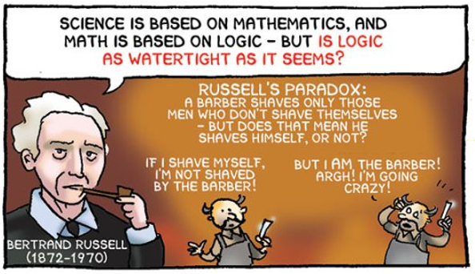

- Review: Define: P(n, k) and $\left(\begin{aligned}n \\ k\end{aligned}\right).$Derive a formula for P(n, k). Using the result for P(n, k), derive a formula for $\left(\begin{aligned}n \\ k\end{aligned}\right).$ Why should 0! be defined to be 1?
- Review: Prove, using only a story proof the following identity.

$$\left(\begin{aligned}n \\ r\end{aligned}\right)=\left(\begin{aligned}n \\ n-r\end{aligned}\right)$$

- Give a story proof (as opposed to a computational proof) for the following identity:
$$\left(\begin{aligned}n \\ r\end{aligned}\right)=\left(\begin{aligned}n-1 \\ r\end{aligned}\right)+\left(\begin{aligned}n-1 \\ r-1\end{aligned}\right)$$

This is known as “Pascal’s identity” even though many mathematicians had “discovered” it before Pascal was born. (Hint: For Pascal’s identity, consider selecting an unordered set of r people from a collection of n people, where one of the n is “Albertine.”)

- Consider the word POISSON.
- Find the number of arrangements of this word.
- Find the number of arrangements if the two Ss must be together.
- Find the number of arrangements if the two Os must be apart.
- Find the number of arrangements if the two Ss must be together and the two Os not together.

- Give a story proof of Vandemonde’s identity, viz.
(Hint: Consider choosing a set of r animals from a collection of m zebras and n sloths.)
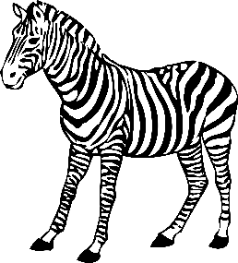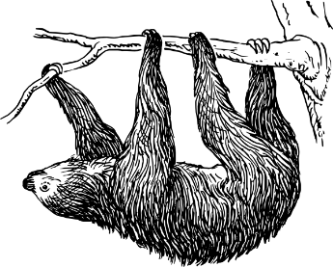
- You are given a group of 13 married couples. In how many ways can one choose a subset of 5 individuals from this group which contains no married couple?
- In how many ways can A, B, C, D, E, F line up if
- A must be in front of B?
- A must be in front of B and B must be in front of C?
- Philanthropist Dave Coke wishes to distribute 7 golden eggs, 6 silver spheres, and 5 platinum cubes to 4 lucky children. In how many different ways can he distribute these precious objects to the four children? (Hint: First consider only the golden eggs.)

- In how many ways can 8 cats stand in a row if
- There are precisely 5 male cats, and they must stand next to one another.
- There are two each of the following colors: tortoiseshell, black, white, blue. Cats of the same color must stand beside one another.

- Albertine lives in a city with a square grid of numbered streets that run east-west and numbered avenues that run north-south. Her house is located on the corner of 0th Street and 0th Avenue. Odette, her aunt, lives at the corner of 5th St. and 3rd Ave.
(a) How long is the shortest route (along streets or avenues) to her aunt’s house?
How many direct routes can Albertine take to her aunt’s house?
(b) There is an ATM at the corner of 2nd St. and 2nd Ave. If Albertine needs to stop at the store on her way to her Aunt’s, how many direct routes to her Aunt’s house take her through the intersection of 2nd St. and 2nd Ave?

- At her Aunt’s house, Albertine hears on the radio that there has been an accident at the corner of 1st St. and 2nd Ave. Assuming that she avoids this intersection, how many direct routes can Albertine take home?

- Consider a standard well-shuffled deck of 52 cards. Swann is dealt (an unordered) hand of 5 cards. In how many ways can he have:
- Ace of diamonds, Jack of spades, 9 of clubs, 9 of spades, and 3 of clubs
- A full-house (containing three cards of one rank and two cards of another rank, such as 3♣ 3♠ 3♦ 6♣ 6♥ )
- Four of a kind.
- Exactly two pairs.
- No two of the same rank.
- No two of the same suit.

