Naïve set theory
3 Sept 2019

Study carefully sections 1.5 – 1.7 of Hammack

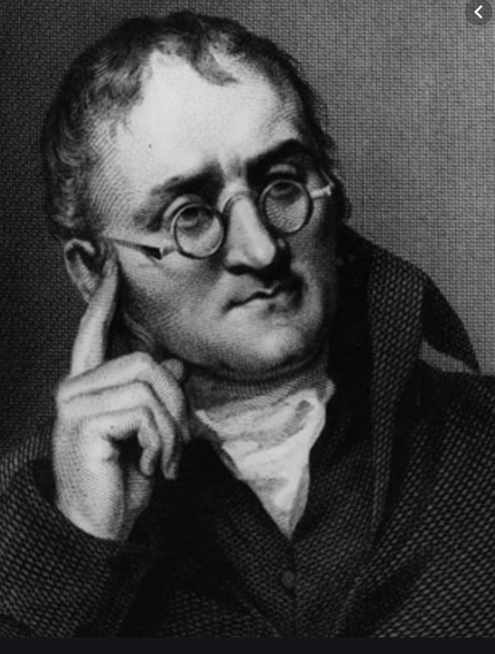
Venn diagrams were introduced in 1880 by John Venn.
They are used to teach elementary set theory.
Venn diagrams are also used to illustrate simple set relationships in
probability, logic, statistics, linguistics and computer science.
- Let A, B and C be three sets such that:
Set A = {2, 4, 6, 8, 10, 12}, set B = {3, 6, 9, 12, 15} and set C = {1, 4, 7, 10, 13, 16}.

Find explicitly, each of the following:

(i) A ∪ B
(ii) A ∩ B
(iii) B ∩ A
(iv) B ∪ A
(v) B ∪ C
(vi) A – B
(vii) A – (B ∪ C)
(viii) A – (B ∩ C)
(ix) Is A ∪ B = B ∪ A?
(x) Is B ∩ C = B ∪ C?
- Out of forty students, 14 are taking English Composition, and 29 are taking Chemistry.
- If five students are in both classes, how many students are in neither class?
- How many are in each class?
- How many students are taking only Chemistry?

- All students have to take at least one math class and one language class. Twenty students take calculus, and thirty students take statistics. Fifteen students take Spanish, and twenty-five take French. If there are thirty-five students total, what is the maximum number of students taking both two math classes and two language classes.

- A vet is examining cats to figure out what is causing an outbreak of a mysterious feline illness. The technician surveyed 87 customers that week. They were asked (1) if the cats were permitted outside, and (2) if the household also has a dog. There were 30 people who said “no” to both questions, and 20 answered “yes” to the outdoors question. While 47 answered “yes” to the dog question, the technician forgot to record how many answered “yes” to both questions. How many was that?

- (corrected) In a group of 39 students, there are 23 who like the Impossible Burger, and the others do not. All the students were asked if they are taking Math or Physics. The responses were:
- 19 are taking Math
- 16 are taking Physics
- 5 who dislike the Impossible Burger are taking Math and Physics
- 9 who like the Impossible Burger are taking only Math
- 1 who dislikes the Impossible Burger takes Physics only
- 3 who like the Impossible Burger are taking both Math and Physics

- How many Impossible Burger lovers take Physics?
- How many students are taking only Math or only Physics?

- Complete each of the following:
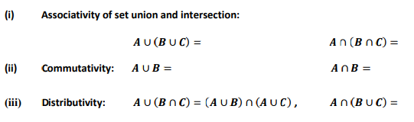
(iv) de Morgan’s laws $\overline{\left(A∪B\right)}=$ $\overline{(A∩B)}=$

(v) Complementation: $A∪\overline{A} =$ $A∩\overline{A} =$

(vi) Double complement: $\overline{\left( \overline{A} \right)}$ =

- True or False? If true, give a Venn diagram argument. If false, provide a counterexample.

(a) 𝐴 ∪ 𝐵 ⊆ A∩B

(b) 𝐴 ∪ (𝐵 ∩ 𝐶) ⊆ (𝐴 ∪ 𝐵) ∩ ( Α ∪ 𝐶)

(c) 𝐴 ∪ (𝐵 ∩ 𝐶) ⊇ (𝐴 ∪ 𝐵) ∩ (𝐴 ∪ 𝐶)

(d) A – (B∩ C) = (A –B) ∪ (A – C)

(e) $A-B=\overline{B}-\overline{A}$

(f) (𝐴 ∪ 𝐵) ∩ 𝐶 ⊇ (𝐴 ∪ 𝐵) ∩ (𝐴 ∪ 𝐶)

- True or False? Here P(X) denotes the power set of X.

(a) P (E) ∩ P (F) = P (E ∩ F)
(b) P (E) ∪ P (F) ⊆ P (E ∪ F)
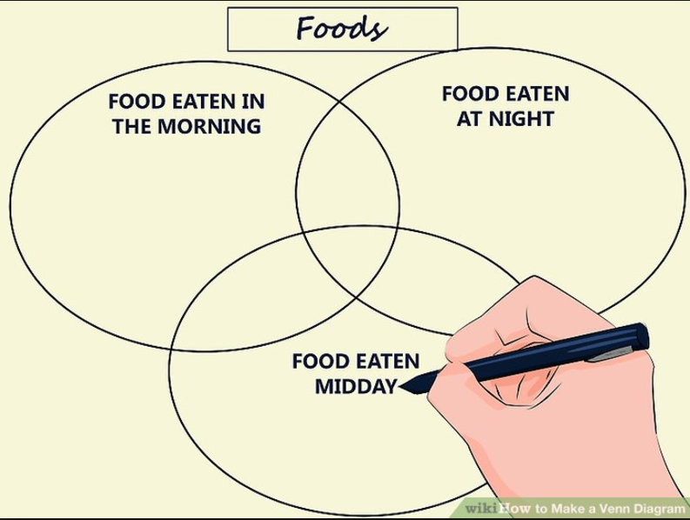

Course Home Page Department Home Page Loyola Home Page

