Homework: MATH 201
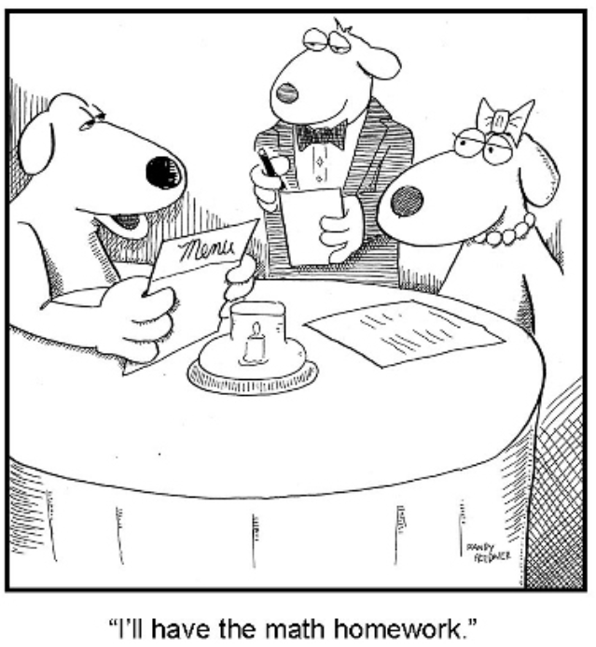
Homework 0: Due: Thursday, 5 Sept.
Briefly relate (in one or two paragraphs) information about yourself that will help me get to know you. If you wish, you may let the following questions serve as a guide: Which other courses in math have you taken or are taking concurrently with Math 201. Why have you chosen to take Math 201 now? (for example: "major requirement", “minor requirement”, "just for fun because I love mathematics", "nothing else fits my schedule", "my parents forced me to take this course", "I am looking for an easy A to raise my GPA"); what is your major?; what is your career goal?; what has been the nature of your previous experience with math either in high school or in college (that is, have you enjoyed math in the past?).
(Please post your response as a private message in Piazza no later than midnight, Thursday. For “Subject” write “201 Homework 0”. Thank you.

Homework 1: Due: Tuesday, 10 Sept.
Read sections 1.1 through 1.7 of Hammack. Note that all of Hammack’s exercises have answers or solutions at the end of the book. So you would profit by doing many of the exercises in these sections and, if you wish, check your answers.
- Answer either (1a) OR (1b) (I hope you find this to be an enjoyable exercise.)
(1a) Rewatch the famous Abbott and Costello video at https://www.youtube.com/watch?v=kTcRRaXV-fg
Write an analysis of whether the language of the video makes any sense.
Either precisely explain why the statements are logical or explain why this routine is nonsense.
Be certain that you are clear and unambiguous in what you write.
(1b) Watch the Colbert video, https://www.youtube.com/watch?v=JgMiS81jFyE
Is this nonsense, or can you instill some logic to this dialogue?
- Explain why the Necker cube is an example of visual ambiguity:
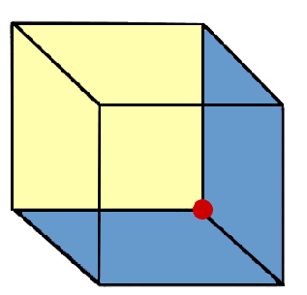
- Explain why each of the following sentences is ambiguous.
- Assume you wish to increase your wealth, would you rather be paid $400 weekly OR $400 biweekly?
- Did you see her duck?
- This is a good sign!
- We don't just serve hamburgers; we serve people.
- Slow children at play.
- Automatic washing machines. Please remove all your clothes when the light goes out.
- Please wait for the hostess to be seated.
- Let X = {0, 1, 2, 3, 4, 5, 6}
- Find |X|
- $Define a function S on P\left(X\right) as follows:$
$$For A∈P\left(X\right), let S\left(A\right) be the sum of all the elements of A.$$
$$For example S\left(\left\{3, 5, 6\right\}\right)=14.$$
Define Y = {A$∈P(X)$| S(A) = 5}.
$$List all the elements of Y. Find \left|Y\right|.$$
- Let A = {4, {0}, {1, 3}}, B = {{1, 2}, 3, 4, {3, 4}, {0}} and C = {{1, 3}, {0, 1, 5}, 3, {4}, {0}, 4}.
Find |B|, |C|, |A$∪$B|, |A$∩$B|, |A – B|, by first listing the elements of each set.
- Let A, B, and C be subsets of the set S. Using only the operators for the union, intersection, difference, and complement as well as the letters A, B, and C, write down expressions for each of the following subsets of S..
(Answers are not unique.)
- at least one subset
- only subset A
- A and B but not C
- all three
- none of the three
- exactly one subset
- at most two subsets
- exactly two subsets

Homework 2: Due: Tuesday, 17 September Review chapter 1 and read sections 1 – 6 of chapter 2.

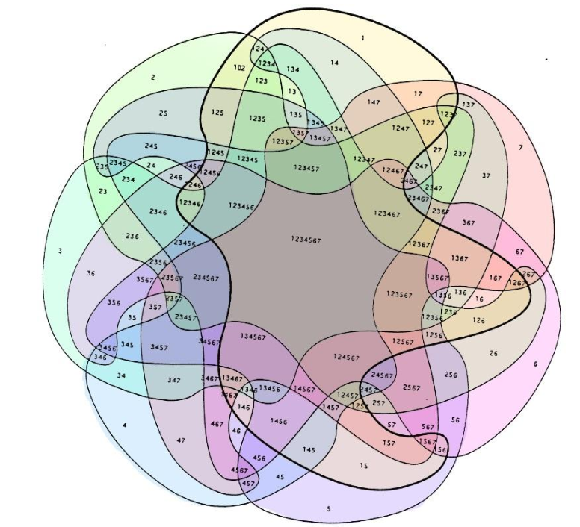
Seven category Venn diagram

- Let X = {p, q}. List all the elements of P(P (X)).
- Let’s consider a propositional language where
- A = “Albertine comes to the party,”
- B = “Boris comes to the party,”
- C = “Cordelia comes to the party,”
- D = “Dmitri comes to the party.”
Formalize each of the following sentences:
- “If Dmitri comes to the party then Boris and Cordelia come too.”
- “Cordelia comes to the party only if Albertine and Boris do not come.”
- “Dmitri comes to the party if and only if Cordelia comes and Albertine doesn’t come.”
- “If Dmitri comes to the party, then, if Cordelia doesn’t come then Albertine comes.”
- “Cordelia comes to the party provided that Dmitri doesn’t come.
- “A necessary condition for Albertine coming to the party is that, if Boris and Cordelia aren’t coming, Dmitri comes.”
- “Albertine, Boris and Cordelia come to the party if and only if Dmitri doesn’t come, but, if neither Albertine nor Boris come, then Dmitri comes only if Cordelia comes but, if Dmitri comes, then Boris doesn’t come”

- Assume that 123 Loyola students are chosen at random. It is learned that 28 are enrolled in CALCULUS, 31 are enrolled in PHYSICS, 42 are enrolled in GERMAN LITERATURE, 9 are enrolled in CALCULUS and PHYSICS, 10 are enrolled in CALCULUS and GERMAN LITERATURE, 6 are enrolled in PHYSICS and GERMAN LITERATURE, 4 are enrolled in all three subjects.
How many students are enrolled in none of the three subjects?
- (a) In propositional logic, modus ponendo ponens (Latin for "the way that affirms by affirming"; generally abbreviated to MP or modus ponens) or implication elimination is a rule of inference. It can be summarized as "p implies q and p is asserted to be true, so therefore q must be true," viz,$\left(p ∧\left(p⇒q\right)\right)⇒q.$ The history of modus ponens goes back to antiquity. Using a truth table, prove modus ponens.
(b) Using a truth table prove that $\sim \left(p⇒q\right) is logically equivalent to p∧\sim q.$
(c) Consider the two sentences $A$ and $B$ defined by:
$$A: \left(p∧q\right)⇒r$$
$$B: p⇒(q⇒r)$$

$Does B⇒A ?$
$Does$ $A⇒ B?$
(Of course, use truth tables to answer these questions.)
(d) Negate each of the following sentences. Hint: Use 3 (b).
$\left(i\right) a ⇒$ b $∧c$
$\left(ii\right) (a∧b) ∨$ ($a$ $∧b)$
$\left(iii\right) \left(a∧b\right)⟺(\sim a ∨\sim b)$
$\left(iv\right) \left(a⇒b\right) ⇒(\sim c ⇒(b⇒a)$
- Proof without words: Using the clever picture below, give a precise and clear explanation of the Arithmetic Mean-Geometric Mean Inequality, viz.
$\frac{a+b}{2}≥\sqrt{ab}$ with equality iff a = b
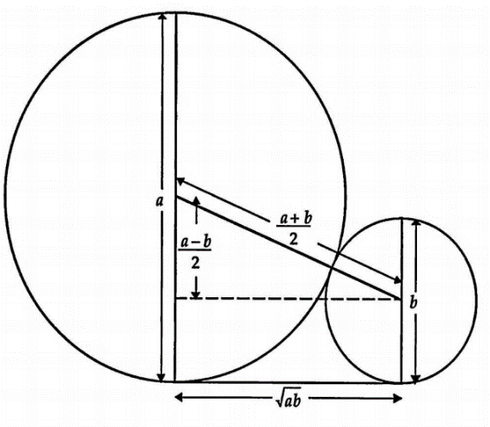
Homework 3: Due: Tuesday, 24 September

Review sections 2.1 through 2.5 of Hammack. Read carefully sections 2.6 through 2.12. Pay particular attention to section 2.10.
Read carefully section 3.1.

The majority of the following exercises from the Book of Proof require little time. They offer a chance to review chapter 2 in preparation for next week's test.
Solve: Section 2.3/ 2, 4, 8, 10,12; section 2.4/ 2, 4; section 2.5/ 2,10;
section 2.6/ 10; section 2.7/ 2, 4, 8, 10; section 2.9/2, 4, 8, 12;
section 2.10 / 2, 4, 8, 10

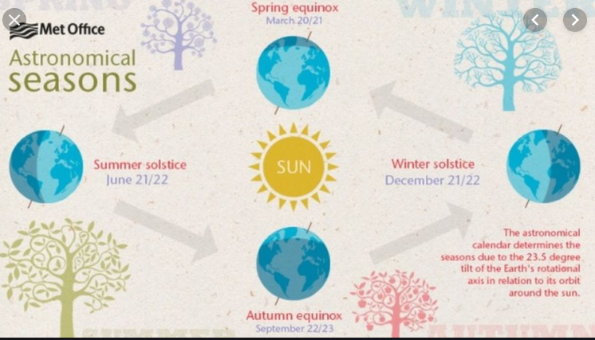

Homework 4: Due: Thursday, 3 October
Review section 3.1. Study sections 3.2 – 3.5. The problems in section 3.8 can be solved without reading section 3.8..
Prepare for Test I.

I (Hammack exercises)
Section 3.3/ exercises 4, 8, 10, 12
Section 3.4/ exercises 8, 10, 16
Section 3.5/ exercises 4, 12, 18
Section 3.8/ exercises 4, 8, 10, 16
II (a) Consider a 2 × 2 × 2 cube, as illustrated below. Charlotte, a spider, wants to travel from A to B; she can only walk on the lines. The path must be the shortest (i.e., 2 up, 2 left, and 2 forward). In how many ways can Charlotte travel?
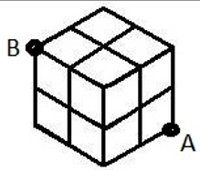
(b) Developing increased self-confidence, Charlotte now wishes to travel on a 3 × 3 × 3 cube subject to the same conditions as in part (a). In how many ways can she travel?
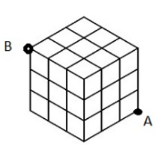
III How many non-negative integer solutions are there to the equation:
(a) x₁ + x₂ + x₃ + x₄ + x₅ = 99?
(b) Same question as (a), but now assume that the solution must consist of positive integers.
(c) Same question as (a) except at least one of the components of a solution (x₁, x₂, x_{3,} x_{4,} x₅) must be 0. For example, 97 + 1 + 0 + 0 + 1 = 99 is one such solution
Homework 5: Due: Tuesday, 15 October
Read carefully sections 10.1 and 10.2 of Hammack.
Solve exercises for chapter 10 (pg 195-916) 6, 8, 10, 12, 16, 18, 20, 34
Homework 6: Due: Thursday, 24 October
Study chapters 4, 5, and 6 of Hammack. Solve the following exercises.

126/ exercise 6, 10, 14;
136/ exercise, 8, 12, 18, 20, 24;
144/ exercise 2, 4, 6, 10, 18, 24

Homework 7: Due: Tuesday, 5 Novermber
Study carefully chapter 7. Pay particular attention to Proposition 7.1 on page 152. Also, study the “well-ordering principle,” the proof of the Division Algorithm (pp. 30 – 31), the definition of gcd, and the proof of Fermat’s little theorem, cf.
https://artofproblemsolving.com/wiki/index.php/Fermat%27s_Little_Theorem.
(Choose your favorite of the four proofs.)

- Using Fermat’s little theorem, compute 3³¹ (mod 7), 29²⁵ (mod 11), and 128¹²⁹ (mod 17).
- Solve 155/ 8, 12, 16, 24, 26. 28, 30, 34
Homework 8: Due: Tuesday, 12 Novermber
Study carefully sections 11.0, 11.1, and 11.2.
Solve: 11.0/ exercises 4, 6, 12; 11.1/ exercises 4, 10, 12, 14; 11.2/ exercises 4, 6, 8
Homework 9: Due: Tuesday, 26 Novermber
Study carefully chapter 12.
Solve: 11.0/ exercises 4, 6, 12; 11.1/ exercises 4, 10, 12, 14; 11.2/ exercises 4, 6, 8.
A summary of basic concepts:
https://brilliant.org/wiki/bijection-injection-and-surjection/
Solve: 12.1/ exercise 6 (first show that f is well-defined!),
12.2/ exercise 4 (first show that f is well-defined!), exercise 6 (first show that f is well-defined!), exercise 10 (first show that f is well-defined!), exercise 12 (first show that f is well-defined!), 14 (first show that f is well-defined!), 16, 18 (first show that f is well-defined!);
12.3 / exercise 4; 12.4 / exercise 6 (first show that f and g are well-defined!), and 8 (first show that f is well-defined!)
Extra credit: 12.3/ exercise 6
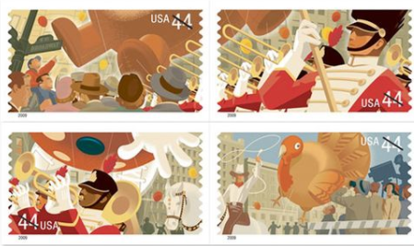
Homework 10: Due: Friday, 6 December
Review sections 12.5, 12.6. Study 14.1, 14.2, 14.3 Study carefully 3.9.
Extra Credit:
Solve: 3.9/ exercises 1 – 4; 12.5/ exercises 2, 6, 8, 10; 12.6/ exercises 2, 4, 8;
14.1/ exercises 12, 16; 14.2/ exercises 10, 12, 14; 14.3/ exercises 6, 8, 10;

- Final Exam: 12/10/2019, Tuesday, 9 am

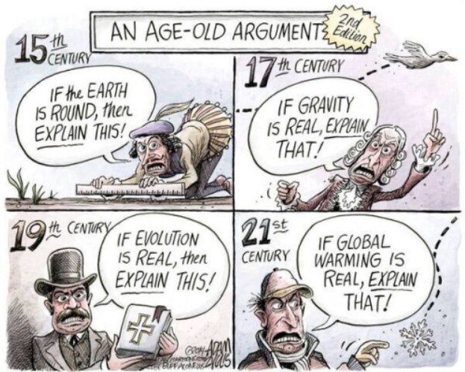

Course Home Page Department Home Page Loyola Home Page

