Math 201 Final Examination 3 May 2019

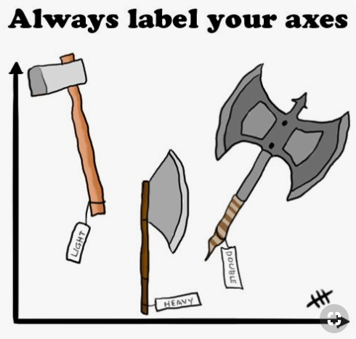

PART A [4 pts each] Answer any 19 of the following 24 questions. You may answer more than 19 to earn extra credit. Give a brief justification for your answer.

- Find 9102! (mod 2019).

- Compute 7²⁰¹⁹ (mod 25).

- Let P be the proposition “Albertine enjoys visiting le Mont-Saint-Michel,”
Q be the proposition “The ocean level is rising,” and
R be the proposition “Elon Musk is Marcel’s favorite celebrity.”
Express as a sentence in English the following logical proposition. Make certain that your sentence is clearly written as well as grammatically correct.
$(\sim$Q) (P $\sim$R)

- Express as a single number.
$\left(\begin{aligned}&2019 \\ & 0\end{aligned}\right)+\left(\begin{aligned}&2019 \\ & 1\end{aligned}\right)+\left(\begin{aligned}&2019 \\ & 2\end{aligned}\right)+\left(\begin{aligned}&2019 \\ & 3\end{aligned}\right)+\left(\begin{aligned}&2019 \\ & 4\end{aligned}\right)+...+\left(\begin{aligned}&2019 \\ &2016\end{aligned}\right)+\left(\begin{aligned}&2019 \\ &2017\end{aligned}\right)+\left(\begin{aligned}&2019 \\ &2018\end{aligned}\right)+\left(\begin{aligned}&2019 \\ &2019\end{aligned}\right)$

- If a, b, x, y Z such that ax + by = 14, prove that the gcd(a, b) cannot equal 3.

- If a ≡ 8 (mod 11) and b ≡ 5 (mod 11), find
a¹⁷⁸⁹ + 2b²⁰¹⁹ + ab + 2019 (mod 11).
- Each of the following statements is ambiguous. Explain two possible interpretations of each. Then rewrite each sentence so that it is no longer ambiguous.
- There is nothing odd about the number of the above sentence.

- To be served, shirts must be worn.

- The children fed the chickens grasshoppers hornworms and June bugs.

- Negate the following sentence. Assume that the universe of discourse is R.

$$∀a∈A ∃b∈B ∃c∈C ∀d∈D ab=cd$$

- Find the units digit of 3164²⁰¹⁹.

- How many natural numbers, less than or equal to 1000, are divisible by either 5 or 11?

- How many non-negative integer solutions exist to the equation
$$x_{1}+x_{2}+…+x_{21}=2019 ?$$

- Let Y be the set of the first 18 positive integers. Prove that if you are given any subset of Y of cardinality 10, then one can find two of them that sum to 19. Justify your answer including naming any theorem that you use along the way.

- Negate: If f is a polynomial and its degree is greater than 2, then $f^{'}$ is not constant.
- Is the following logically correct? Explain.
Timon: Away! what art thou?
Flavius: Have you forgot me, sir?
Timon: Why dost ask that? I have forgot all men;
Then if thou grant’st thou’rt a man, I have forgot thee.

- Shakespeare, Timon of Athens, Act 4, scene 3

- Let L be the set of all current Loyola students. Define a relation on L as follows:
For a, b L, a b if a and b have the same blood type.
Is this an equivalence relation? Briefly justify your answer.

- Is the following logically correct? Explain.

Lucky will buy a house only if Pozzo buys a car. Pozzo will buy a car only if Estragon buys a motorcycle. Estragon will not buy a motorcycle. So Lucky will not buy a house.

- Find the largest prime that divides 2019!

- Consider the set of all sequences of 10 ones and 5 zeroes. How many such sequences exist that contain a run of 3 zeroes and another run of 2 zeroes (but no run of five zeroes)?
For example 001110001111111

- Consider a standard deck of 52 cards. In how many ways can one be dealt a 9-card hand (without regard to order) that contains no Queens, no fives, and no sevens?

- Let $X=Z.$For c and d $∈Z$, let us define the binary operation ☹ as follows:
c ☹ d = c^{d} + d^{c} + 2019
Is X closed under the operation ☹? Justify your answer.

- Suppose |A| = |B| = 19. How many bijections exist from A to B?

- Suppose that |C| = 2019 and |D| = 4321. How many injections exist from C into D?

- In how many ways can you draw a hand (without regard to order) of 9 cards from a standard deck of 52 that consists of 4 of a kind, 3 of a kind, and a pair?
(For example, $\{$3, 3, 3, 3, 5, 5, Q, Q, Q}

- If it is now 4:15 pm, what time will it be in 20,192,019 hours?

- Given that the function f: Z × Z → Z × Z defined by the formula
$f\left(m,n\right)=(5m+4n, 4m+3n)$ is bijective, find its inverse.

- Given a function f: A → B and subsets W, X ⊆ A, prove that f (W ∩ X) ⊆ f (W)∩ f (X).

PART B [10 pts each] Answer any four of the following 5 problems. You may solve all 5 to earn extra credit.
- If A, B, and C are sets, prove that (A ∩ B) − C = (A − C) ∩ (B − C).
- Suppose x, y ∈ Z. If x²(y + 3) is even, prove that x is even or y is odd.
- Using the principle of mathematical induction, prove that, for all integers n 1:

- Let P denote the statement “Number Theory is fascinating,” Q denote the statement “The exercises are challenging,” and R denote the statement “The course is fun.” Write each of the following statements in symbolic form:
- Number Theory is fascinating, and the exercises are challenging.
- Number Theory is not fascinating, the exercises are not challenging, and the course is not fun.
- If Number Theory is not fascinating and the exercises are not challenging, then the course is not fun.
- Either Number Theory is fascinating, or the exercises are not challenging, but not both.Let {f_{n}} be the Fibonacci sequence (defined recursively):
f₁ = f₂ = 1;
f_{n+2} = f_{n+1} + f_{n} for n 1.
- Using mathematical induction prove that:

Riddles: [2 pts each]

- When the day after tomorrow is yesterday, today will be as far from Wednesday as today was from Wednesday when the day before yesterday was tomorrow. What is the day after this day?

- Romeo and Juliet are found dead on the floor in a bedroom. When they were discovered, there were pieces of glass and some water on the floor. The only furniture in the room is a shelf and a bed. The house is in a remote location, away from everything except for the nearby railroad track. What caused the death of Romeo and Juliet?

- The police, acting on an anonymous phone call, the police raid a house to arrest a suspected murderer. They do not know what he looks like, but they know his name is Samuel and that he is inside the house. The police bust in on a carpenter, a lorry driver, a mechanic and a firefighter all playing poker. Without hesitation or communication of any kind, they immediately arrest the firefighter. How do they know they have their man?

