Math 201 Practice Final Examination B

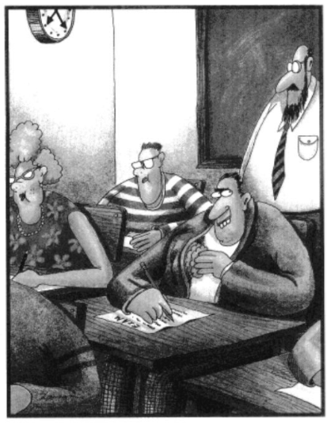  Midway through the exam, Allen pulls out a bigger brain.  – The Far Side  Part I (Computational)  Instructions: Answer any 10 of the following 12 problems. You may answer more than 10 to earn extra credit. Each problem is worth 10 pts. Show your work. | Maximum time = 3 hours

- Let A and B be sets satisfying |A| = 99 and |B| = 177.
- Find the number of maps from A into B.

- Find the number of injective maps from A into B.

- Find the number of injective maps from B into A.

- Find the number of surjective maps from A into B.

- Negate the following sentence:
- Find 2²⁰ + 3³⁰ + 4⁴⁰ + 5⁵⁰ + 6⁶⁰ (mod 7)

- Albertine lives in a city with a square grid of numbered streets that run east-west and numbered avenues that run north-south. Her house is located on the corner of 0th Street and 0th Avenue. Odette, her aunt, lives at the corner of 6th St. and 3rd Ave.
(a) How many blocks are required by any shortest route (along streets or avenues) to her aunt’s house?

(b) How many direct routes (that is, shortest routes) can Albertine take to her aunt’s house?

(c) There is an ATM at the corner of 4th St. and 2nd Ave. If Albertine needs to stop at the store on her way to her Aunt’s, how many direct routes to her Aunt’s house take her through the intersection of 4th St. and 2nd Ave?

- Consider the set, B, of all binary sequences consisting of four zeroes and eight ones.
(a) Find |B|.
(b) How many sequences in B have the property that no two consecutive terms are both zero?
(c) How many sequences in B have all four zeroes together?

- Negate the following sentences:
- The numbers x and y are both even.

- I don’t eat anything that has a face.

- Find the remainder when $4^{987}∙ 3^{2017 } is divided by 5.$

- There are exactly three types of students in a school: the geeks, the wannabees, and the athletes. Each student is classified into at least one of these categories. And the total number of students in the school is 1000. Suppose that the following is given:
The total number of students who are geeks is 310.
The total number of students who are wannabees is 650.
The total number of students who are athletes is 440.
The total number of students who are both geeks and wannabees is 170.
The total number of students who are both geeks and athletes is 150.
The total number of students who are both wannabees and athletes is 180.
What is the total number of students who fit into all 3 categories?
- Find 1! + 2! + 3! + … + 9999! + 100,000! (mod 7). Show your work!

- You are dealt a hand of 7 cards from a shuffled deck of 52 cards.
(a) How many hands are royal flushes?
(A royal flush is a hand that consists of 4 of a kind and 3 of a kind).
- How many hands consist of only Jacks, Queens, Kings, and Aces?
- How many hands contain no two cards of the same rank? (That is, includes no pair.)

- Let X be a set of cardinality 2019.
(a) How many elements are in $P(X)$?
(b) How many elements of $P(X)$ contain at least one member?
(c) How many elements of $P(X)$ contain at least 1234 members? (That is, how many $A ϵ P(X)$ have the property that |A| ≥ 1234?)
- Four distinguishable frogs are being fed 7 indistinguishable flies.
(a) In how many ways can the 7 flies be fed to the 4 frogs (with no conditions)?
(b) In how many ways can the 7 flies be fed to the 4 frogs if each frog must be fed at least one fly?

Part II (Theory)

Instructions: Answer any 12 of the following 15 problems. You may answer more than 12 to earn extra credit. Each problem is worth 10 pts. Show your work.

In each proof, clarity and precision are as crucial as having the right ideas!

- Given that $a≡b \left(mod n\right) and c≡d \left(mod n\right), prove that ac≡bd \left(mod n\right).$

- Prove that there do not exist integers, x, and y, such that
135x + 3141y = 1
- Let A and B be subsets of X.
Prove (using our method of proving set equality) that A – B = B^{c} – A^{c}
- Let X be a non-empty set. Define $T: P(X)$→ $P\left(X\right)$by $T$(A) = A^{c}.
Is $T$ a bijection? If so, give a proof. If not, explain why.
- Prove, using induction, that 17n³ + 103n is divisible by 6 for all p0sitive integers n.
- Let X be a non-empty set and let Y = $P\left(X\right).$Define the following relation (called the symmetric
difference) on Y:
$$A ∆ B=\left(A-B\right)∪\left(B-A\right)$$
- Let X be the set of all integers. Let A = {1, 2, 3}, and B = {3, 4}. Find$A ∆ B.$.
- Is $∆$reflexive? Explain.
- Is $∆$ symmetric? Explain.
- Is $∆$transitive? Explain.

- Define a relation $⨂$on the set of real numbers by:
$a⨂$b means $∃k∈Z a-b=2kπ$
Is $⨂$ an equivalence relation? If so, prove it. If not, explain why.

Prove that, for all positive integers, n, if n³ + 5 is odd, then n is even.

- Let $F$: X →Y and $G$: Y →Z be mappings.
Assume that $G∘F is injective.$ Prove that $F$ must be injective

- Prove, using mathematical induction, that, for any positive integer n,
n³ + 2n is divisible by 3.
- Prove, using induction, that n! > 2^{n} for all integers, n ≥ 4.

- Prove that the cube root of 7 is irrational.

- Prove that $P→Q and \left(\sim P\right) \bigvee{Q}$ are logically equivalent.

- Let P be the proposition “Time is out of joint,”
Q be the proposition “The bee population is declining,” and
R be the proposition “Dark” is Marcel’s favorite TV series.”

- Express as a sentence in English the following logical proposition. Make certain that your sentence is clearly written as well as grammatically correct.
Q ($\sim$P R)

- Express the following sentence in symbolic form.

“If Dark is Marcel’s favorite TV series and the bee population is not declining, then time is out of joint.”

- Prove that the set of irrational numbers is uncountable. You may state any lemmas that you need without proof. (Consequently, your proof should be quite brief.)

Extra Extra Credit: Riddles of Lewis Carroll
  - No experienced person is incompetent.
Jenkins is always blundering.
No competent person is always blundering.
Assuming that the three statements above are true, what conclusion can you draw?
  - A Russian had three daughters. The first, named Rab, became a lawyer; the second, Ymra, became a soldier. The third became a sailor; what was her name?

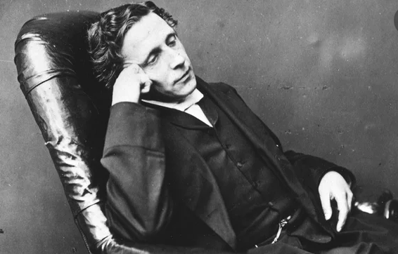
  - Dreaming of apples on a wall,
And dreaming often, dear,
I dreamed that, if I counted all,
How many would appear?

– Charles Lutwidge Dodgson (aka Lewis Carroll), 1832 – 1898

