Math 201: Preparing for test 2
17 October 2019

Chapter 3 (sections 1 – 5, 7 (special case), 8 – 10);
Chapter 10 (sections 1 & 2);
Chapters 4 – 6 (as much as we cover on Tuesday)
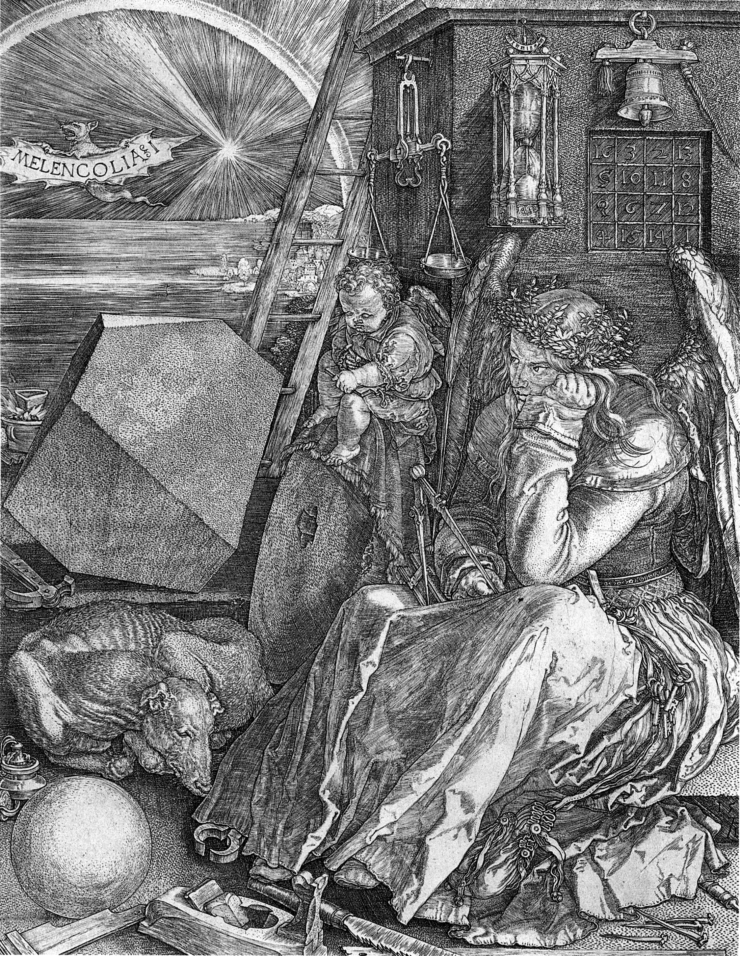
Albrecht-Dürer, Melancholia

(Note the magic square in the background.)

- Types of problems:
- counting: permutations, combinations, stars & bars
- proofs (direct, cases, induction (ordinary & strong), contrapositive, contradiction, if and only if, conditional)
- definitions in the case of number theory (odd, even, divisibility, prime number, etc.)
- fill in the blank
- True/False
- find a counter-example
- given proof with a missing part, fill in the missing part
- given a false “proof,” correct it
- inclusion/exclusion principle (special case)

Practice problems:
- Consider the set of all binary sequences of length 10. How many such strings exist if
- No condition?
- Exactly three 1s?
- First digit and last digit must be 0?
- The first digit or last digit must be 0?
- The sum of the digits is 7?

- Let n be an integer. Prove that n³ + n² + n is even if and only if n is even.
- Given integers, p and q prove that if both pq and p+q are even, then both p and q are even using
- Proof by contrapositive
- Direct proof
- Given integers c and d, where c ≥ 2, prove, using the method of contradiction, that either $c∤d$ or $c∤\left(d+1\right).$
- Let a and b be non-zero integers. Then we say write a|b if _________________________.
- The two basic steps in a proof by induction are called:
- __________________________________
- ___________________________________
- Explain why every integer can be expressed in the form 5n, 5n+1, 5n+2, 5n+3 or 5n+4.
- Find the flaw in the following “proof”:
(from A. J. Hildebrand, notes from University of Illinois)
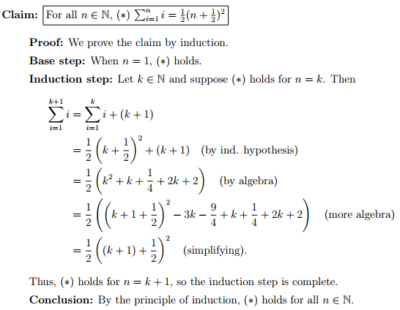
- Explain Euclid’s argument (by contradiction) that there are infinitely many primes.
- Prove, using strong induction, that every integer greater than 1 can be factored into primes.
- In class, we proved that, for all natural numbers n, any 2^{n} × 2^{n} punctured chessboard could be tiled by tri-ominos. Prove independently that 3 must be a divisor of 2^{2n} – 1
- Albertine is teaching Chem 105 this semester. She has a total of 100 students in her class. Taking a survey (via Piazza), she finds that 28 students like dogs, 26 like cats, and 16 like rats. There are 12 students who like cats and dogs, 4 who like dogs and rats, and 6 who like cats and rats. Only 2 students like dogs, cats, and rats. How many students do not like any of the 3 animals: dogs, cats, rats.
- Three distinguishable dice are thrown. In how many ways can the maximum of the 3 numbers occurring equal 5?
- If you are dealt a hand of 7 cards from a standard deck (without regard to order), how many ways can you have:
- A flush? (all 7 of the same suit)
- 3 pairs (excluding 4 of a kind)?
- 4 of a kind and one pair (excluding 3 of a kind)?
- 4 of a kind and no other pair?
- No pair at all?

- Find the flaw in the following bogus proof. Explain!
- Step 1: Let a = b.
- Step 2: Then a² = ab
- Step 3: Then a² + a² = a² + ab
- Step 4: Then 2a² = a² + ab
- Step 5: Then 2a² – 2ab = a² + ab – 2ab
- Step 6: Then 2a² – 2ab = a² – ab
- Step 7: This can be written as 2(a² – ab) = 1(a² – ab)
- Step 8: Dividing each side by (a² – ab) yields 1 = 2

- Consider a group of 11 American students {A, B, C, …, J, K} visiting the Louvre. In front of La Giaconda, they line up at random for a photograph to be taken by their tour guide. In how many ways can the 11 students line up so that B and C are side-by-side?

- (a) If a Martian has an infinite number of red, blue, yellow, and black socks in a drawer, how many socks must the Martian pull out of the drawer to guarantee it has a pair?

- A box contains 6 red, 8 green, 10 blue, 12 yellow, and 15 white balls. What is the minimum no. of balls we have to choose randomly from the box to ensure that we get 9 balls of same color?
- Consider the equation x₁ + x₂ + …+ x₅ = 99
  - How many solutions are there in non-negative integers?
  - How many solutions are there in positive integers?
- Prove that if x and y are irrational, must x + y or xy be irrational as well?

