MATH 201 Practice Problems for Test III
(Revised)
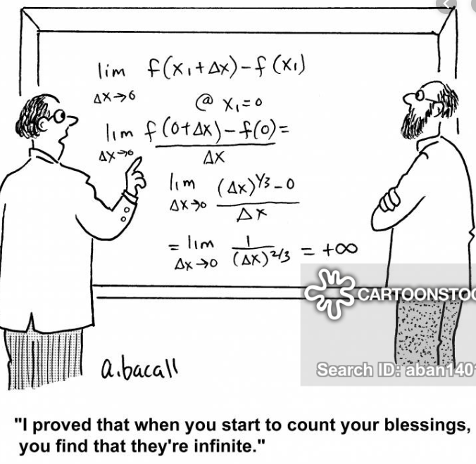

- For any real numbers, c and d, let us define the binary operation ☺ as follows:
c ☺ d = c² + d² – 1
Give either a brief justification or counterexample for each of the following assertions:

- The set of integers is closed under the operation ☺ .
- The set of even integers is closed under the operation ☺ ?
- The set of odd integers is closed under ☺.
- The set of positive integers is closed under ☺.
- The set of rational numbers is closed under ☺.
- The set of irrational numbers is closed under ☺.
- Let S be the set of all polynomials for which odd powers of x (i.e., 1, 3, 5, 7,…) do not appear.
For example, 4 + ½ x² – π x⁸ $∈S, but x^{2}-\frac{5}{4}x^{81} ∉S$.
(a) Is S closed under the operation of differentiation? Why?
- Is S closed under the operation of taking the second derivative?
- Is S closed under the operation multiplication by x³?
- Is S closed under the operation multiplication by x⁴?
(e) Is S closed under the following unary operation, ● ?
For all $p∈S define Πp as follows: Πp=$p$(1+ x^{4})$
Note: $Πp means$ that polynomial p is evaluated at 1 + x⁴
(f) Is S closed under the following binary operation ?
For all $p∈S p=$p$(1+x)$ Here as before, we interpret p(1 + x) is the polynomial p evaluated at 1 + x.
- Define the following binary relation R on N. For c, d ∈ Z⁺, cRd if |c – d | < 5. (Justify each answer!)

(a) Is R reflexive? Why?
(b) Is R symmetric? Why?
(c) Is R transitive? Why?

- Define the binary relation R on a non-empty set, S, of books as follows:
For a, b ∈ S, aRb if book a costs more and contains fewer pages than book b. (Justify each answer!)

(a) Is R reflexive? Why?
(b) Is R symmetric? Why?
(c) Is R transitive? Why?

- Again, let S be a non-empty set of books. Let H be the binary relation defined by:
for a, b ∈ S, aHb if book a costs more or contains fewer pages than book b. (Justify each answer!)
(a) Is H reflexive? Why?
(b) Is H symmetric? Why?
(c) Is H transitive? Why?

- Let x and y be real numbers. Prove that if x² + 5y = y² + 5x. Prove that either x = y or x + y = 5.
- Using the Euclidean algorithm, find the gcd of 7701543 and 3141
- Using the method of contrapositive proof, prove each of the following statements:
- Suppose that x, y $∈$ Z. If x²(y + 3) is even, prove that x is even or y is odd.
- Let a $∈$Z. Prove that if a² is not divisible by 4, then a is odd.

- Prove that there exist no integers a and b for which 390a + 63b = 1.

- Use Fermat’s little theorem to show that 17 divides 11¹⁰⁴+1.

- Prove that $\sqrt{6}$ is irrational.

- Let a $∈$Z. Prove that $a^{3}≡a \left(mod 3\right).$

- Let a, b $∈$Z. Prove that (a – 3)b² is even if and only if a is odd and b is even.

- The three most recent appearances of Haley’s comet were in the years 1835, 1910, and 1986.
The next occurrence will be in 2061. Prove that 1835¹⁹¹⁰ + 1986²⁰⁶¹ $≡0 \left(mod 7\right).$

- Find 2013¹³ (mod 13)

- Let W be the set of all words in the 2019 edition of the Oxford English dictionary. Define xRy if x and y have at least one letter in common. Is R reflexive? Symmetric? Transitive?

- Let A= R³. Let a∼b mean that a and b have the same z coordinate. Does this define an equivalence relation?
- Let S be a finite set and A=P(S), the power set of S. For any a,b∈A, let a∼b mean that a and b have the same cardinality (that is the same number of members).
Show that ∼ is an equivalence relation. Compute the equivalence classes when S ={1,2,3}.
- The following purports to prove that the reflexivity condition is unnecessary, that is, it can be derived from symmetry
and transitivity:
Suppose a∼b. By symmetry, b∼a. Since a∼b and b∼a, by transitivity, a∼a. Therefore, ∼ is reflexive.
What's wrong with this argument?
- True or False? Explain.
- If R is an equivalence relation on a finite non-empty set A, then the equivalence classes of R all have the same number of elements.
- Let R be a relation defined on the set Z by aRb if a ≠ b. Then R is symmetric and transitive.
- Define GCD. Prove that gcd(n, m) = gcd(n + m, m).
- Show that gcd(n, m) = gcd(n − m, m).
- Give an example to show that gcd(n, m) = gcd(n + m, n − m) need not be true.
- Suppose that n is even and gcd(n, m) = 5. Show that m is odd.
- Find all numbers k with 0 ≤ k ≤ 100 such that gcd(100, k) = 5.
- (a) Show that there is no integer x satisfying the equation 2x + 1 = 5x – 4

(b) Show that there is no integer x satisfying the equation 18x² + 39x – 7 = 0

(c) Show that the system of equations
11x – 5y = 7
9x + 10y = -3
has no integer solution.

- Let A = {1, 2, 3, 4, 5}, and let
R = {(1, 1), (1, 3), (1, 4), (2, 2), (2, 5), (3, 1), (3, 3), (3, 4), (4, 1), (4, 3), (4, 4), (5, 2), (5, 5)} define an equivalence relation on A. (You may wish to check this!) Which of the following is an equivalence class?
- {1, 2, 3} b) {2, 3, 5} c) {1, 3, 4} d) {1, 2} e) {1, 2, 3, 4, 5}
- State Euclid’s lemma. Prove that gcd(a, bc) = 1 if and only if gcd(a, b) = 1 and gcd(a, c) = 1.
- Let X denote the set of all continuous functions on [0, 1].
- Is X closed under addition, subtraction, multiplication, division?
- Is X closed under composition? Differentiation?
- Let A be the set of all polynomials in the variable x. Is A closed under:
- Addition, subtraction, multiplication, composition, differentiation?
- Consider the unary operations in A defined by, for $p∈A$
$\left(i\right) U\left(p\right)=p\left(2x\right);$ (ii) U(p) = $p^{''}\left(x\right)+4p^{'}\left(x\right)+xp\left(x\right).$ (iii) U(p) = x²p(x)
Under which of these operations is A closed?
- (a) Prove that $\log_{2}{5 }$is irrational.
(b) Find 2²⁰¹⁹ mod 17
- Find 2²⁰¹⁹ mod 33.
- Find the units and ten digits of (984321)(454443)(444555).

- Let Y be the power set of a finite non-empty set F.
- Is Y closed under complements?
- Is Y closed under union? Intersection?

