Extra credit: Essay topics for Math 201
April 2019
Write a 3 – 5 page essay on one of the following topics. Your paper will be evaluated based on content, style, grammar, and originality. Be certain to give credit to all of your sources (including those on the web) at the end of the paper. Quality is far more important than quantity. Avoid dullness.
Due date: 26th April 2019
- Read chapter 2 (The mysteries of infinite sets) of Vilenkin’s In Search of Infinity. This chapter includes the “infinite hotel.” Discuss your personal reaction.
https://yakovenko.files.wordpress.com/2011/11/vilenkin1.pdf.

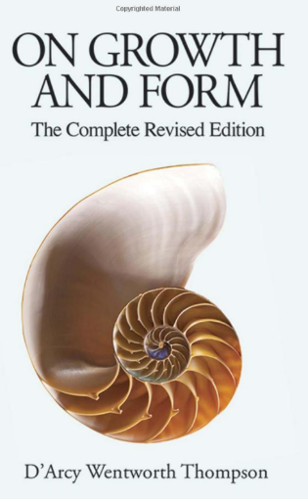
- D’Arcy Thompson’s On Growth and Form, Cambridge University Press; (1992). (first written in 1917, revised by Thompson in 1942) has been called by Nobel laureate P. Medawar "the finest work of literature in all the annals of science that have been recorded in the English tongue." Others have called him “the first bio-mathematician." The central thesis of On Growth and Form is that zoologists of his time overemphasized the role of evolution, and underemphasized the roles of physics and mathematics as determinants of the form and structure of living organisms. Perhaps the most famous part of the work is Chapter IX (of the abridged version), "On the Theory of Transformations, or the Comparison of Related Forms." Here Thompson explores the degree to which differences in the forms of related animals could be described using relatively simple mathematical transformations. Choose a topic or an example from Thompson that particularly intrigues you; describe and discuss this example in your paper. Explain why you find this topic remarkable.

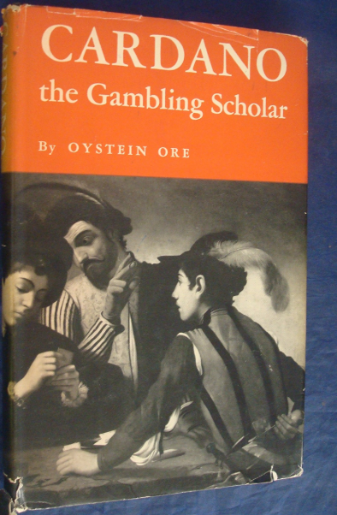
- Discuss the discovery of the solution to the cubic equation, drawing from the lives of Tartaglia and Cardano. You may wish to read portions of the lively text by Orstein Ore, Cardano: The Gambling Scholar, Dover (1965).

- Imagine that you are writing to a well-educated friend in a distant land (or perhaps in an isolated location such as a maximum-security prison). In your text, you wish to convey a profound intellectual or emotional experience (such as joy, wonder, ecstasy, bewilderment) in learning a topic or theorem in Math 201. Your goal is to communicate your passion for mathematics to your distant friend. For example:
Dear Albertine,
We were devastated by the news that the Saudi government denied your appeal for a new trial. Nonetheless, we are confident that one-day justice will prevail and you will be released. Since you are not permitted to receive any packages, let this letter serve to share with you my joy and amazement at my most recent epiphany in Discrete Mathematics and Number Theory ….

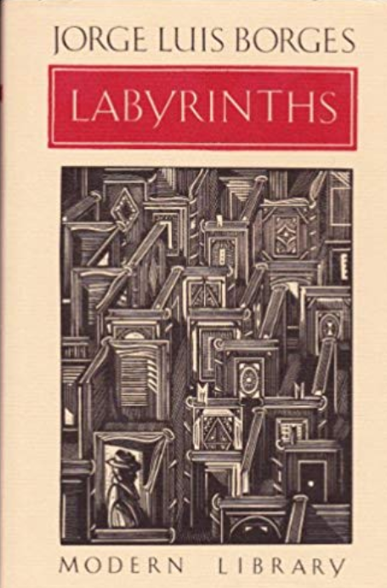
- The renowned Argentine writer, Jorge Luis Borges, was fascinated by the infinite. Read several of the short stories in Borges’ Labyrinths: Selected Stories and Other Writings. Discuss the relationship between the study of the infinite in the differential calculus and Borges’ vision of the infinite. Alternatively, write a short story in the style of Borges that engages the reader in a particular encounter with the differential calculus.

In addition to Borges’ fascination with the infinite, there continue to be many examples of how our culture is fascinated by tales of the infinite. For example, consider the recent song, The Bottomless Hole, written and performed by the Handsome Family. Explore and discuss other contemporary examples of our culture’s fascination with the infinite.

- Read David Foster Wallace’s idiosyncratic book, Everything and More: A Compact History of Infinity, W. W. Norton (2003). You will find fascinating discussions about the paradoxes of infinity. Explore his thesis that “However good calculus is at quantifying motion and change, it can do nothing to solve the real paradoxes of continuity….” (p. 145).

- What is the Continuum Hypothesis? What were the contributions of Cantor, Gödel, Cohen?

- Stephen Jay Gould, in his brilliant work, The Mismeasure of Man, Norton (1996), argues forcefully how misuse of science and mathematics have been used as an instrument of discrimination, using the I.Q. test as a significant example. Read and discuss your personal reaction to this work that is regarded by many as “a major contribution toward deflating pseudo-biological ‘explanations’ of our present social woes.”

Read Nate Silver’s critically acclaimed book, The Signal and the Noise: Why So Many Predictions Fail -- But Some Don't, Penguin Press (2012) in which“Silver examines the world of prediction, investigating how we can distinguish a true signal from a universe of noisy data. Most predictions fail, often at great cost to society, because most of us have a poor understanding of probability and uncertainty. Both experts and laypeople mistake more confident predictions for more accurate ones. But overconfidence is often the reason for failure. If our appreciation of uncertainty improves, our predictions can get better too. This is the ‘prediction paradox’: The more humility we have about our ability to make predictions, the more successful we can be in planning for the future.” Discuss how this book has influenced your views toward predicting the future.

- Difficult: What is the Banach-Tarski paradox? What is the axiom of choice? Transfinite induction?

- Peruse Smullyan’s Logic of Puzzles https://qedinsight.wordpress.com/2011/04/01/the-logic-puzzles-of-raymond-smullyan/ Also read the brief articles: http://www.enthusiasticallyconfused.com/Mathematics/Riddles%20%26%20Puzzles/Raymond%20Smullyan/The%20Lady%20of%20the%20Tiger%20and%20Other%20Logic%20Puzzles%20-%20Smullyan.pdf

https://www.nytimes.com/2017/02/11/us/raymond-smullyan-dead-puzzle-creator.html

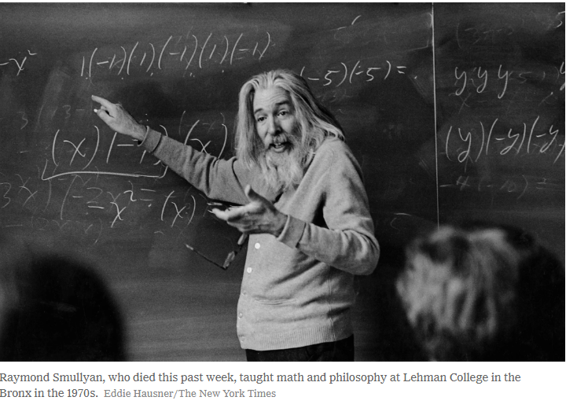

- You may wish to choose a topic not listed here. If so, you must obtain prior approval from your instructor.
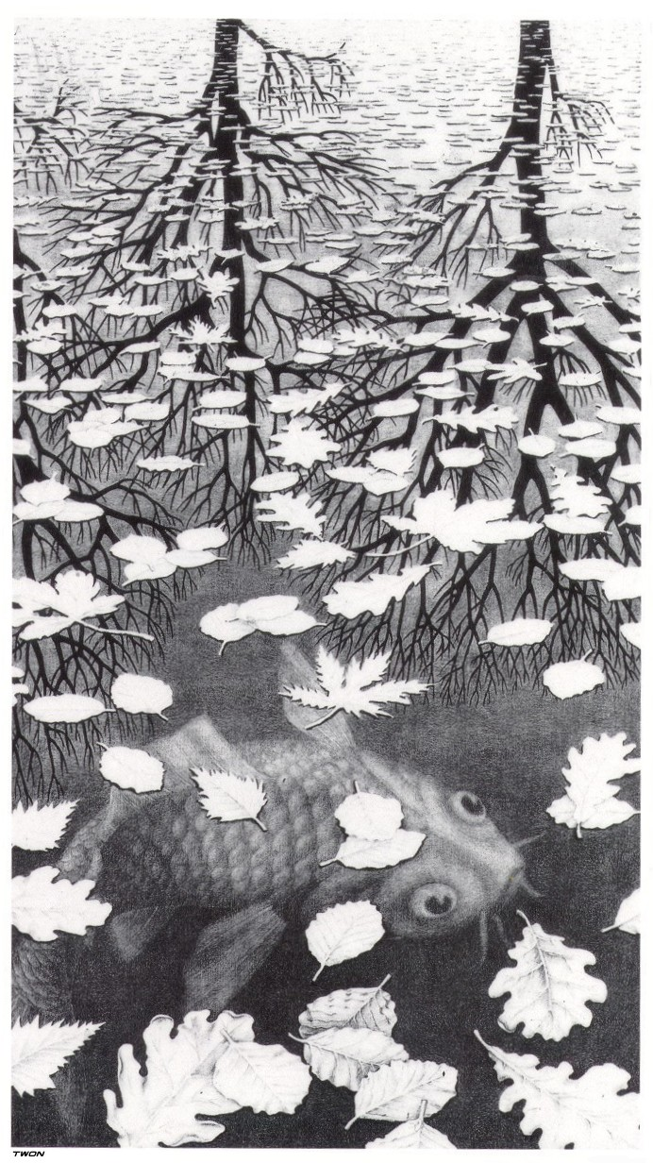
Three Worlds, M. C. Escher

