MATH 201 TEST I 26 September 2019
Name: _____________________

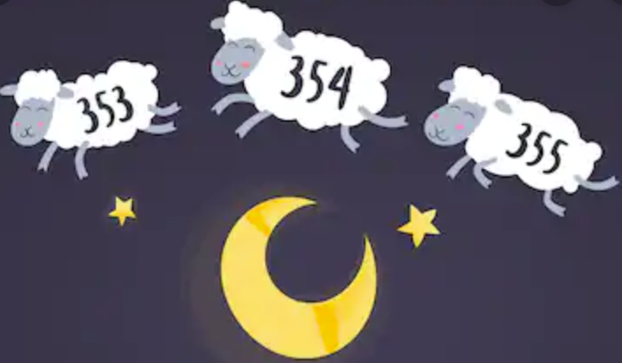

“Don’t count the days; make the days count.”
― Muhammad Ali

Instructions: Answer any 8 of the following 10 problems. You may answer more than 8 to earn extra credit.

- Suppose p is false, q is false, s is true. Find the truth value of
- (s ∨ p) ∧ (q ∧ $\sim$s)

- (p ∧ ~q) ∨ $\sim$s

- $\sim$(p∧$\sim$q) ∨$\sim$p

- Which of the following three formulas best represents the sentence
“There is a computer which is not used by any student”?

- $∃x\left(Computer\left(x\right)∧ ∀y\left(\sim Student\left(y\right)∧\sim Uses\left(y,x\right)\right)\right)$

- $∃x\left(Computer\left(x\right)→ ∀y\left(Student\left(y\right)→\sim Uses\left(y,x\right)\right)\right)$

- $∃x(Computer\left(x\right) ∧ ∀y\left(Student\left(y\right)→\sim Uses\left(y,x\right)\right)$
Briefly justify your choice.

- Negate the following sentence:
$$∀a∈A ∃b∈B ∃c∈C abc≠0$$

- Let B(x, y) be the predicate meaning “x bought y” where x is a member of a set of people and y is a member of a set of objects that are for sale.

Using words such as “everyone,” “someone,” “nobody,” etc., translate the following into English sentences:

- bought(Albertine, drone)

- $∃x bought(Albertine, x)$\

- $∀x \left(bought\left(Albertine, x\right)→bought\left(Swann, x\right)\right)$

- $\left(∀x\left(bought\left(Albertine, x\right)\right)→∀x bought(Swann, x)\right)$

- $∀x ∃y bought(x, y)$

- $∃x ∀y bought(x,y)$

- Consider a standard deck of 52 cards. In the following, do not attempt to simplify your answers.

- In how many ways can you line up 5 cards (this means order matters!) such that each black card is followed by a red card and each red card is followed by a black?

- In how many ways can you line up 8 cards so that at least one of them is black?

- In how many ways can you line up 4 cards so that exactly one is a spade?

- In the land of Oz it has been decreed that every password must be exactly 11 characters in length, contain exactly one capital letter {A, B, C..., Z}, exactly one lower case letter {(a, b, c, ..., z}, and exactly one of three special characters {#, $, @}. The remaining characters must be digits {0, 1, 2, ... , 9}.
- How many such passwords exist?

- In how many ways can you be dealt 5 cards from a standard deck of 52 (without regard to order) in such a way that you have one “three of a kind” and one “pair”?

- (i) Is (p → q) ∨ (p → $\sim$q) always true? Justify your answer.

(ii) Is $(\sim p)∨q$ logically equivalent to $p→q$ ? Briefly justify your answer.

- An urn contains 46 balls, each of which is distinguishable from all the other 45 balls: black, 11 white, 12 red and 13 blue.
In how many ways can you choose
- 9 balls such that exactly 3 are red?

- 8 balls such that at least one is blue?

- Write the negation (in English) of each of the following sentences:

- The speed limit is 80 mph, and granny is driving at 35 mph.

- Granny is driving at 35 mph only if the speed limit is not 80 mph.

- If granny is not driving at 35 mph, then the speed limit is not 80 mph.

- In the Oz School of Learning, there are 180 students. Every student is taking at least one foreign language. One hundred and ten of the students study French, 88 study German, and 65 study Arabic. Forty students study both French and German, 38 study only German. Five lucky students are taking all three languages. Find the number of students who study:

- German only

- Arabic only

- Only two languages

- For each “identity” below determine whether it is True or False. If True, justify using Venn diagrams; if False, give a particular counterexample.
- $A∪\left(B∩A\right)=B$

- $\left(A∪B\right)-\left(A∩B\right)=A$

