MATH 201 Solutions: TEST II 17 October 2019
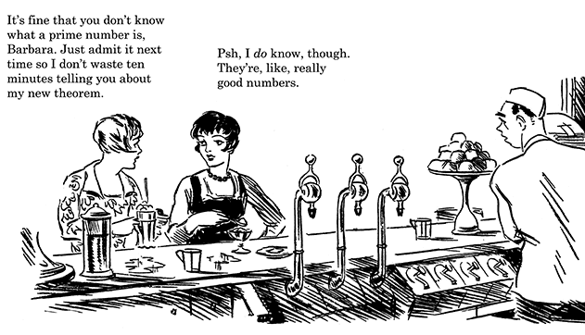
Instructions: Answer any 8 of the following 9 problems. You may answer all 9 to earn extra credit.
- Let p, q, r be integers.
- Assume that p ≠ 0. Define p|q.

Answer: p|q means $∃k∈Z q=pk.$
- Assume that p ≠ 0. If $p\left|q and p\right|r prove that p|\left(q+r\right)$
Solution: $Since p\left|q and p\right|r ∃s, t∈Z q=ps and r=pt.$
$$Now q+r=ps+pt=p\left(s+t\right).$$
$$Since s+t∈Z, it follows that p|\left(q+r\right).$$
- Assume that p ≠ 0 and q ≠ 0. If $p\left|q and q\right|r prove that p|r$.
Solution: $Since p\left|q and q\right|r ∃s, t∈Z q=ps and r=qt.$
Hence $r=qt=pst=\left(st\right)p. So p|r.$

- Albertine lives in a city with a square grid of numbered streets that run east-west and numbered avenues that run north-south. Her house is located on the corner of 0th Street and 0th Avenue. Odette, her Aunt, lives at the corner of 6th St. and 3rd Ave.
- How many blocks are required by any shortest route (along streets or avenues) to her aunt’s house?

- How many direct routes (that is, shortest routes) can Albertine take to her Aunt’s house?

- There is an Apple store at the corner of 4th St. and 2nd Ave. If Albertine needs to stop at the store on her way to her Aunt’s house, how many direct routes to her Aunt’s house take her through the intersection of 4th St. and 2nd Ave?

- (a) Let x, y, z be integers for which 15x + y = 25z – 625 . Must y be divisible by 5? Explain.

(b) Prove that if n is an integer then 5n² + 3n + 13 is odd. Hint: Use cases.

- Consider the set of all binary sequences of length 11. How many such strings exist if
- no condition?

- the fifth, sixth, and seventh digits must be the same?
- there are at least 9 zeroes?
- there are exactly 8 ones, and no two zeroes are side by side?
- (a) The two basic steps in a proof by induction are called:

- Base case
- Induction step

(b) Prove that $7^{n}-1$ is a multiple of 6 for all n ∈N.
Solution:
We use the method of mathematical induction.
For all n ∈ N, let P(n) be the statement that $7^{n}-1$ is a multiple of 6.
Step 1: P(1) asserts that $7^{1}-1$ is a multiple of 6. This is indeed true since $7^{1}-1=6.$

- Consider the following recursively defined sequence a₁, a₂, a₃, …
a₁ = 4 and $∀n≥1 a_{n+1}=\frac{1}{2}(a_{n}+8)$
- Write the first five terms of the sequence.
Answer: a₁ = 4, a₂ $=\frac{ 1}{ 2}\left(a_{1}+8\right)=\frac{1}{2}\left(4+8\right)=12$

- Prove, using mathematical induction, that $∀n≥1 a_{n}≤8$

- Three distinguishable dice are thrown. In how many ways can
- all three numbers be distinct?

- the sum of the numbers be 4?

- exactly two of the three numbers be the same?

- If you are dealt a hand of 9 cards from a standard deck (without regard to order), in how many ways can you have
- no pair at all?

- a flush (that is, all 9 of the same suit)?

- 3 three-of-a-kind (eg, 3 aces, 3 fives, 3 nines)

- 4 of a kind and no other pair?

- Madame Verdurin has 45 indistinguishable coins, each of one franc. In how many ways can she
- distribute the 45 coins to 12 children?

- distribute the 45 coins to the children subject to the condition that each child must receive no fewer than 2 francs.

- distribute the 45 coins subject to the condition that not every child receives money. (This means that at least one child receives no coins.)

- Now Madame Verdurin has 12 distinguishable pies. In how many ways can she distribute these 12 pies amongst the children?

Extra Extra Credit: Riddles of Lewis Carroll
- No experienced person is incompetent.
Jenkins is always blundering.
No competent person is always blundering.
Assuming that the three statements above are true, what conclusion can you draw?

- What is most like a bee in May?
"Well, let me think: perhaps—" you say.
Bravo! You're guessing well, to-day!
Explain.

- A Russian had three daughters. The first, named Rab, became a lawyer; the second, Ymra, became a soldier. The third became a sailor; what was her name?

- Dreaming of apples on a wall,
And dreaming often, dear,
I dreamed that if I counted all,
How many would appear?

- When the King found that his money was nearly all gone and that he really must live more economically, he decided on sending away most of his Wise Men. There were some hundreds of them—very fine old men, and magnificently dressed in green velvet gowns with gold buttons: if they had a fault, it was that they always contradicted one another when he asked for their advice—and they certainly ate and drank enormously. So, on the whole, he was rather glad to get rid of them. But there was an old law, which he did not dare to disobey, which said that there must always be
"Seven blind of both eyes:
Two blind of one eye:
Four that see with both eyes:
None that see with one eye."
(Query. How many did he keep?)

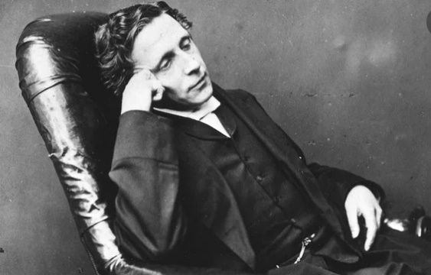
– Charles Lutwidge Dodgson (aka Lewis Carroll), 1832 – 1898

