**Worksheets:  MATH 117**

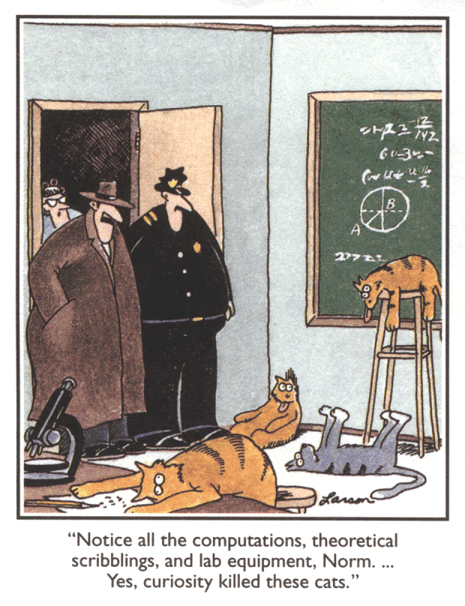

[16 January 2018](http://www.math.luc.edu/~ajs/courses/117spring2018/ws/ws1Jan16.pdf) introduction, relations

[18 January 2018](http://www.math.luc.edu/~ajs/courses/117spring2018/ws/ws2Jan18.pdf) functions

*Work!  God wills it.  That, it seems to me, is clear.*

                 - Gustave Flaubert  (letter to Louise Colet, 1845)

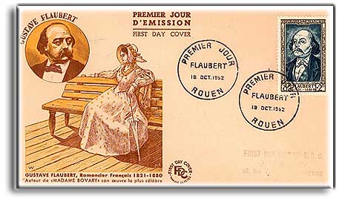

[Course Home Page](http://www.math.luc.edu/~ajs/courses/117spring2018/index.pdf)          [Department Home Page](http://www.math.luc.edu/)        [Loyola Home Page](http://www.luc.edu/)