**MATH 100 Practice problems for TEST II**

**15 October 2019**

1. The points (1, -2), (3, t), and (7, 22) lie on a straight line. Find the value of *t*.

**2.** Albertine is planning to open a Halloween punch stand, and she needs to purchase equipment and ingredients to make the Halloween punch. If she decides to make a total of 20 gallons of punch, the equipment and ingredients will cost her a total of 84 dollars. However, if she decides to make 35 gallons, it will cost her 110 dollars.

Let C(x) be the cost to Albertine, in dollars, of producing *x* gallons of Halloween punch. Assuming C(x) is a linear function, ﬁnd a formula for C(x).

**3**. Odette has $500 to spend on papayas and pumpkins for a Halloween party. Each organically grown papaya costs $4, and each pumpkin costs $9. The number of pumpkins, *y*, is a function of the number of papayas she decides to buy, *x*.

1. Find an equation relating *x* and *y*.
2. Interpret the practical meaning of the *x* and *y* intercepts in the context of the party.

*Answers:* The x-intercept represents _________________________

The y- intercept represents _________________________

**4**. Find an equation of a line that

1. passes through the point (7, 13) and is parallel to the line 3x – 6y = 89.
2. has x-intercept -13 and y-intercept 18.
3. Passes through the point (1, 2) and is perpendicular to the line 4x + 8y = 2019
4. Has x-intercept of 5 and passes through *the point of intersection* of the two lines

3x – 8y = 48

7x + 3y = 40

**5.** Consider the straight line y = x – 1. For each of the following points determine if it

(1) lies *on* the line; (2) lies *below* the line; or (3) lies *above* the line.

1. (2, 0
2. (4, 3)
3. (3, 2)
4. (1, -2)
5. (6, 8)
6. Find a *possible* equation for the line that is perpendicular to the graph

of 5x - 3y=15 if the two lines intersect at x=15. Give an exact answer.

1. Could the table represent a linear function?

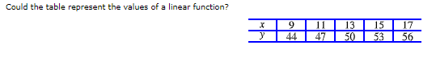

1. A gram of fat contains 9 dietary calories, whereas a gram of carbohydrates. contains only 4.  
   **(a)**Write an equation relating the amount f, in grams, of fat and the amount c, in grams, of carbohydrates that one can eat if limited to a total of 2200 calories/day.  
   **(b)** The USDA recommends that calories from fat should not exceed 30% of all calories. What does this tell you about f?  
   Round your answer to the nearest integer.  
   A 2200-calorie diet should include no more than about https://edugen.wileyplus.com/edugen/art2/common/pixel.gif grams of fat.
2. Without solving the equations, decide how many solutions the system has.

5y = -4 + x x = 4 + 5y

1. Solve the following systems of equations or explain why no solution exists that is, the system is *inconsistent*). If the system has infinitely many solutions (that is, the system is dependent), then so state.
2. 7x+5y=-111 35x + 25y = -1
3. 3x – y = 10 5x – 9x = -20
4. 3x + 4y = 10 4x + y = 9
5. 3x = 7y 12y = 5x – 1
6. 3x – y = 8 33x – 11y = 88
7. $\frac{3}{x} +\frac{4}{y} =22 \frac{5}{x}-\frac{1}{y}=6$ Hint: Make a change of variables.
8. The miles per gallon, M(v), of Albertine’s Porsche is a function of her speed, *v*, in mph. What is the practical meaning of M(81) = 23 ? (Answer using a complete sentence.)
9. Starting salary (measured in thousands of dollars), F(t), in the land of Oz is a function of the number of years, *t*, of schooling (beginning in the First Grade). What is the meaning of F(14) = 19 ? (Answer using a complete sentence)
10. Odette has $400 to spend on apples and Evian for a Halloween party. A six-pack of Evian costs $8 and an apple costs $3. The number of six-packs she can afford, *y*, is a function of the number of apples she decides to buy, *x*.

(a) Find an equation relating *x* and *y*.

1. Interpret the *x* and *y*-intercepts in the context of the party.

1. Determine whether the expression is a quadratic expression in x. If so, write the expression in standard form and state the values of a, b, and c.
2. 1 – 7x2 – 12x
3. 9x2 – 5
4. (x – 1)2 – 5x2
5. For each graph below, a graph of the form y=ax2+bx+c is given. State whether the values a and c are positive, negative, or zero.

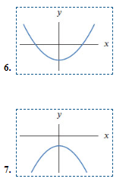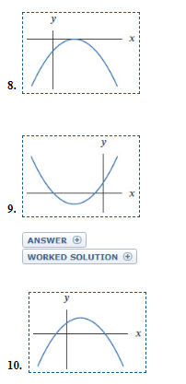

1. In AlphaVille the temperature is measured in EUCLID degrees In BetaVille, temperatura is measured in GAUSS degrees. You are told that 5 Guass degrees equals 8 Euclid degrees, and that 24 Gauss degrees equals 68 Euclid degrees. Find a relationship between Gauss degrees and Euclid degrees.
2. If the Widget Company charges x dollars per ítem, it finds that it can sell 1500 – 3x of them. Each item costs $5 to produce.
3. Express the revenue, R(x), as a function of price.
4. Express the cost, C(x). as a function of price.
5. Express the profit, P(x), which is revenue minus cost, as a fuinction of price.
6. Dmitry drops a ball from the top of a tower. Its height above the ground in feet t seconds after it is dropped is given by 100 – 16t2.
7. Explain why the 16 tells you something about how fast the ball is falling.
8. When dropped from the top of a tree, the height of the ball at time *t* is 120 – 16t2. Which is taller: the tower or the tree?
9. When dopped from a building on Mars, the height of the ball is given by 10 – 20t2. How does the height of the building compare to the height of the tower? How does the motion of the ball on Mars compare to its motion on Earth?