Math 117 Practice Problems for Test II

(revised: 26 march)



1. Consider the following piecewise defined function:

$$f\left(x\right)=\left\{ \begin{aligned}1-x if x<0 \\ 2x^{2} if 0≤x≤5 \\ 3 if 5<x≤9 \\ 4 if x>9\end{aligned}\right.$$

Find the value of each of the following: f(5), f(-12), f(-1), f(9.71)

1. Consider the graph of y = f(x) below:

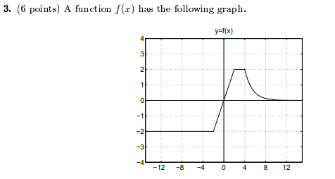

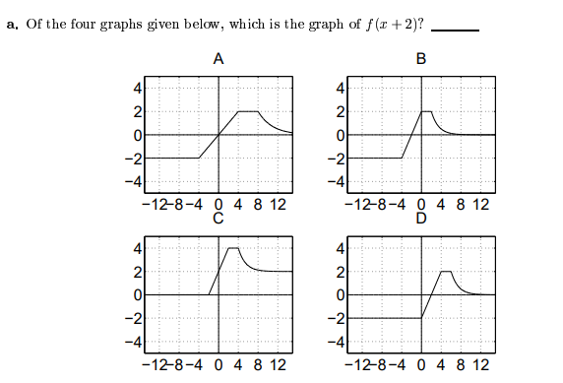

b) Write a formula in terms of f for the function whose graph is given in the figure below.

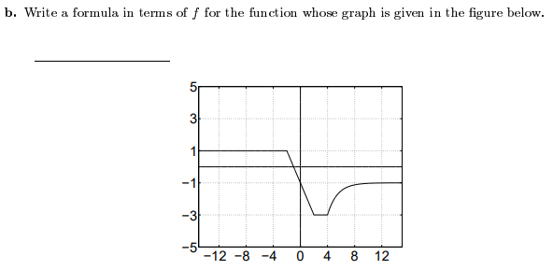

1. If y = g(x) has domain [0, 1] and range of [2, 3], find the *domain* and *range* of y = 1 +3g(4x – 5).

1. Data from three functions is shown in the table below. One function is linear, one is a power function, and one is neither of these. Determine which set of data is linear. Then find a corresponding formula.

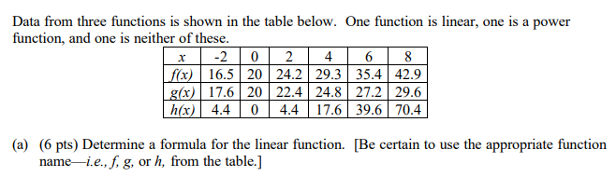

1. . Let y = F(x) be a function with domain [-6, 2] and range [-4, 4]. The graph of *F* is displayed below.

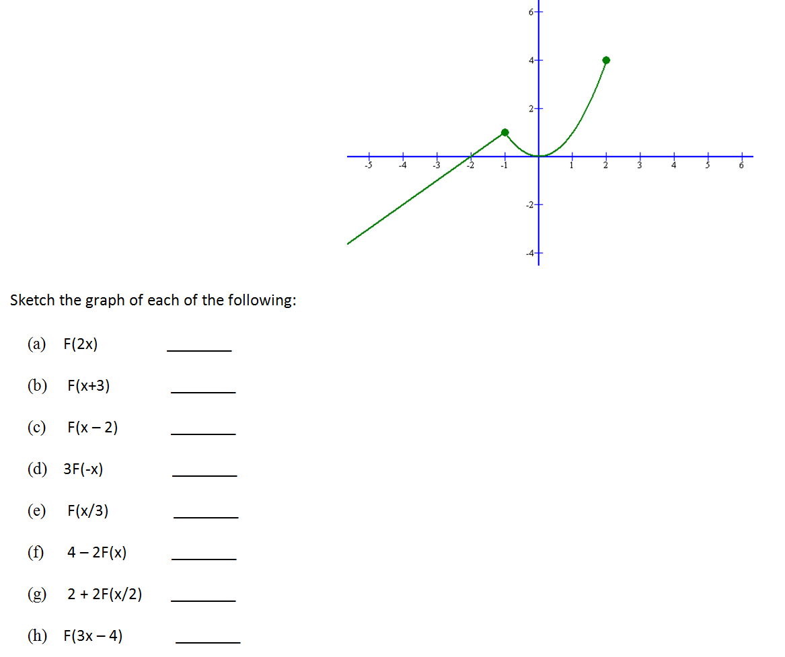

Sketch the graph of each of the following:

1. F(x + 3)
2. F(x – 2)
3. 3F(x)
4. F(x) – 8
5. F(x – 5) + 3
6. 5F(x) – 4
7. (Note: The question below may not have unique answer.)

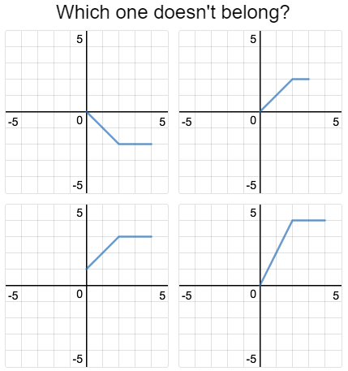

1. Let y = f(x) = x2. Explain what happens to the graph of *f* if we perform the following transformations. Sketch the graphs of the transformed functions.
2. y = f(x) – 1
3. y = 8 – f(x)
4. y = f(x – 5)
5. y = f(x – 1) + 4
6. Has the *domain* or *range* changed for any of the above? *Explain!*
7. Let V(t) = t2 – 4t + 4 represent the velocity after t seconds of an object in meters per second.

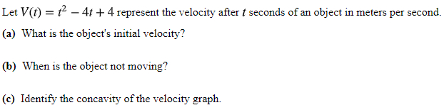

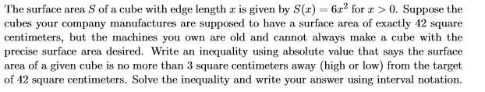

1. Find the zeros of Q(r) = 2r2 − 6r −36 by factoring.
2. Suppose that the relationship between Fahrenheit and Celsius is linear and that 0 degrees Celsius corresponds to 32 degrees F, and that 100 deg C corresponds to 212 deg F.

Find a formula for deg C as a function of deg F, then find its inverse.

What temperature values in deg. Celsius are equivalent to the temperature range 50 F. to 95 F.

1. Find the zeros of Q(x) = 5x − x2 + 3 = 0 using the quadratic formula.
2. For each of the following functions, compute **the average rate of change** over the interval [x, x + h].

(a) f(x) = x3

(b) f(x) = 1/x

(c) f(x) = (x + 4)/(x – 5)

(d) f(x) = 4x2 + 3x – 13

(e) f(x) = 1/x.

1. Without a calculator, graph y = 3x2 – 16x – 12 by factoring and plotting zeroes.

1. Let V(t)=t2 − 4t + 4 represent the velocity after *t* seconds of an object in meters per second.

**(a)**What is the object's initial velocity?

**(b)**When is the object not moving?

**(c)**Identify the concavity of the velocity graph.

(d) When is the object not moving?

(e) Identify the concavity of the velocity graph.

1. For each of the following assume that y = f(x) is the graph written in an unbroken curve. Express each transformation (dashed line), as an appropriate function of f.

|  |  |  |
| --- | --- | --- |
|  | |  |
|  | |  | | |

1. If y = f(x) has domain [-1, 1] and range of [2, 3], find the *domain* and *range* of

y = 1 + f (4x – 5).

1. Find two different quadratic function with zeroes x = 1 and x = 2.
2. The height of an object dropped from the roof of an eight story building is modeled by:

H(t) = -16t2 + 64, 0 ≤ t ≤ 2. Here, H is the height of the object off the ground in feet, t seconds after the object is dropped. Find and interpret the average rate of change of H over the interval [0, 2].

1. Find an equation of a quadratic function that corresponds to the graph below:

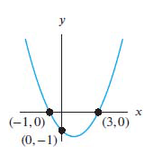

1. Graph f(x) with all of these properties:

* f(0) = 5
* f is decreasing and concave up for −∞ < x < 0
* f is increasing and concave up for 0 < x < 6
* f is increasing and concave down for 6 < x < 8
* f is decreasing and concave down for x > 8

1. Using the *quadratic formula*, solve for the roots of each of the following:

(a) y = x2 – 4x + 1

(b) y = 2x2 – 5x + 1

(c) y = 4x + 1 – 3x2

(d) y = 1 – x – x2

1. *Without solving*, determine the *number of roots* that each quadratic has:
2. y = x2 + 5
3. y = x2 – 18x + 81
4. y = 5x – 4 – x2
5. The temperature *T*, in degrees Fahrenheit, *t* hours after 6 AM is given by:



What is the warmest temperature of the day? When does this happen?

1. Suppose C(x) = x2 − 10x + 27 represents the costs, in hundreds of euros, to produce x thousand pens. How many pens should be produced to minimize the cost? What is this minimum cost?
2. The height of an object dropped from the roof of an eight-story building is modeled by

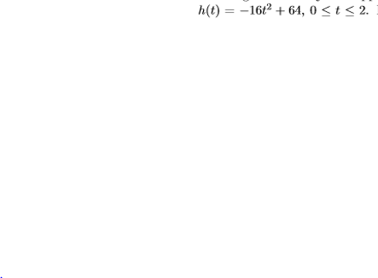

Here, h is the height of the object oﬀ the ground, in feet, t seconds after the object is dropped. How long will it take until the object hits the ground?

1. The height *h* in feet of a model rocket above the ground t seconds after lift-oﬀ is given by



When does the rocket reach its maximum height above the ground? What is its maximum height?

1. Gilberte’s friend Swann participates in the annual Games of Oz. In one event, the hammer throw, the height h in feet of the hammer above the ground t seconds after Jason lets it go is modeled by



What is the hammer’s maximum height? What is the hammer’s total time in the air? Round your answers to two decimal places.

1. Find the *domain* of the functions

(a)  (b) f(x) = $\frac{x(x-3)(x-5)}{x+99}$

1. Consider the function g(x) = x4 – 7x2 – 6x. Circle the numbers below that are roots of g. (There may be several or perhaps none.) Show your work.
2. 0 (b) 1 (c) -1 (d) 2 (e) -2 (f) 3 (g) -3 (h) 7
3. Let g(x) = 2x2 + x + 1. Compute and *simplify* the expression



1. *[University of Michigan precalculus final exam]*  In this problem, the constants *a, b, c,* and *d* are all *positive and different from each other*. Consider the function:



(a) What is the y-intercept of *G*? If there is not a y-intercept, write *NONE*.

(b) Find all zeroes of *G*. If there are no zeroes, write *NONE*.

1. Find the *domain* of each of the following functions. *Explain!*

(a)  (b) 

1. Let F(x) = 31 – $\frac{1}{x^{3}}$. Here is a plot of *F*.



1. What is the *domain* of F?
2. What is the *range* of F?
3. . Suppose that 

(a) If f(x) = $1+\sqrt{x+9}$  
find a function *g* such that 

(b) If f(x) = $1+\sqrt{x}$  
 find a function *g* such that 

(c) If g(x) = $\sqrt{\frac{x+3}{x+1}+9}$ find a function *f* such that 

1. Suppose that 
   1. If  find a function *g* such that 
   2. If  find a function *g* such that 
   3. If find a function f such that 
2. *How many real roots* does each of the following equations possess? (*Hint:* These questions require very little calculation.)
3. (x – 1) (x + 5) (x2 + 13)4 = 0
4. x2 – 4x – 1 = 0
5. (x4 + 2)(x + 1)(x2 – 9) = 0
6. Find functions *f* and *g*, each simpler than the given function *h*, such that 









1. Find an equation of a polynomial that has zeroes at x = 1, 4, 5 and has y-intercept of 11.
2. Consider the polynomial

y = f(x) = –x2(x – 2)4(x – 3)5(x – 5)(x2 + x + 1)

1. The domain of *f* is:
2. The zeroes of the polynomial are:
3. Consider y = f(x), a rational function that has the graph below:

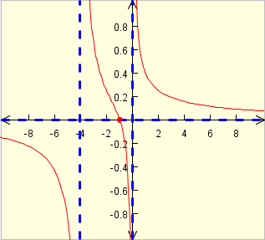

1. Find the domain.
2. List the zeroes.
3. Find a polynomial p(x) that has roots 1, 2, -3, -4 and satisfies the property that p(-1) = 5.
4. Explain the significance of the *discriminant of a quadratic expression*

Ax2 + Bx + C. Give examples of each of the three *types* of discriminants and their relationship to the corresponding graph of the parabola.

1. *How many real roots* does each of the following equations possess? (*Hint:* These questions require very little calculation.)
   1. (x – 1) (x + 5) (x2 + 13)4 = 0 (b) (x4 + 2)(x + 1)(x2 – 9) = 0
2. Let p(x) = x2 + x – 2 and q(x) = x2 + 1. Compute and simplify each of the following:
3. 4p (x) (b) (p + q) (x)
4. (p – q) (x) (d) (3p + 5q) (x) (e) (pq) (x)

(f) $p∘q(x)$ (g) $q∘p(x)$ (h) $q∘q(x)$

1. Let p(x) = (x – 2)2(x2 + x + 1)3(x2 – 14x + 45). Find all the zeroes of *p*.
2. Find a number *b* such that 4 is a zero of the polynomial p(x) = x3 – 2x2 + bx + 1.
3. Find a polynomial of third degree having roots (i.e., zeroes) of 1, 7, 11.
4. Let p(x) = x3 – 2x2 + x. For each given point, determine if it lies *on* the graph, *above* the graph, or *below* the graph of y = p(x).
5. (1, 1), (b) (2, 1), (c) (3, 12), (d) (-1, -5)
6. For each of the following functions, determine *domain, zeroes.* y = (x – 1) (x – 2) (x – 3)
7. y = (x – 1)2 (x – 2)3 (x – 3)
8. y = x4 (x + 5)2 (x – 3)4
9. 
10. 
11. 
12. 
13. 
14. 
15. 
16. 
17. Match each story with the table and graph which best represent it.

* (a) When you study a foreign language, the number of new verbs you learn increases rapidly at first, but slows almost to a halt as you approach your saturation level.
* (b) You board an airplane in Philadelphia heading west. Your distance from the Atlantic Ocean, in kilometers, increases at a constant rate.
* (c) The interest on your savings plan is compounded annually. At first your balance grows slowly, but its rate of growth continues to increase.

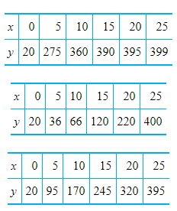 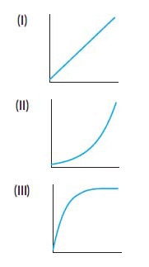

1. An incumbent politician running for reelection declared that the number of violent crimes is no longer rising and is presently under control. Does the graph shown below support this claim? Why or why not?

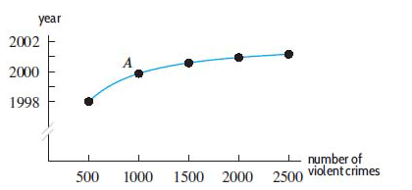

1. Using the quadratic formula, solve for x: x2 – 3x – 1 = 0

1. Calculate successive rates of change for the function, R(t), in the table below to decide whether you expect the graph of R(t) to be concave up or concave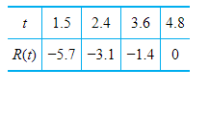
2. Sketch a graph that is everywhere negative, increasing, and concave down.
3. Sketch a graph that is everywhere positive, increasing, and concave up.

1. Let S(d) give the height of high tide in Seattle on a specific day, d, of the year. Use shifts of the function S(d) to find formulas for each of the following functions:

**(a)** T(d), the height of high tide in Tacoma on day d, if we assume that high tide in Tacoma is always one foot higher than high tide in Seattle.

**(b)** A(d), the height of high tide in Astoria on day d, if we assume that high tide in Astoria is the same height as the previous day's high tide in Seattle.

*The limits of my language mean the limits of my world.*

- Ludwig Wittgenstein, **Tractatus Logico-Philosophicus**(1922)