**Class discussion: 15 February 2019**

Chain rules

Review: Clairaut’s theorem, tangent planes

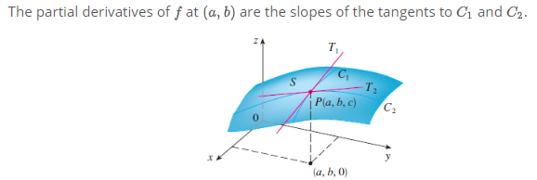

Review:

1. (Stewart)  Find the value of $\frac{∂z}{∂x}$ at the point (1, 1, 1) if the equation

xy + z3x – 2yz = 0

defines z as a function of the two independent variables x and y and the partial derivative exists.

1. Let u(x, y, z) = exp(xy) + z cos x.  Find all nine second-order partial derivatives.
2. Using Clairaut’s Theorem, compute

(a) fxyxyxy if f(x,y) = x2 tan(ey + y + y2)

(b) fxxxyy if f(x,y) = x4y3 – y arctan(ln x + sin x)

1. . (*Math 21a, Harvard*) Consider the following four functions:

(a) f(x, y) = ex cos y; (b) f(x, y) = x3 – 3xy2;

(c) f(x, t) = exp(–(x + t)2); (d) f(x, t) = sin(x – t) + sin (x + t).

Each function above is a solution to one of the four (famous) partial differential equations listed below. Determine the correspondence.

*Laplace Equation:* fxx + fyy = 0 *Wave Equation:* ftt = fxx

*Heat Equation:* ft = fxx *Transport Equation:* ft = fx

1. Find an equation of the *tangent plane* to each of the following surfaces at the given point:

(a) z = x + 3y + 7 at P = (1, 2)

(b) z = y2 –x2  at the origin

(c) z = ln(x + y) + xey at Q = (1, 0)

(d) z = sin(3x + 4y) at the origin

1. Now we will exploit the fact that the tangent plane is the *best linear approximation* to a surface at a given point.

(a) By *roughly how much* will f(x, y) = x (x2 + y2)1/2 change as one moves from point P = (4, 3) a distance ds = 0.1 unit in the direction of the vector **a** = 2**i** – 3**j** ? Compare this to the actual value of the change.

(b) By *roughly how much* will g(x, y) = ex cos y change as one moves from the origin a distance ds = 0.2 unit in the direction of the vector **b** = 5**i** + 12**j** ? Compare this to the actual value of the change.

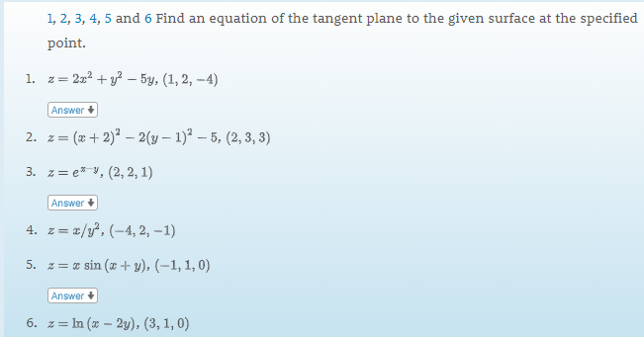

1. State the special case of the Chain Rule: $\frac{d}{dt }$ f(r(t)

Express this result in terms of the gradient of f.

1. Compute (d/dt) f(**r**(t))

(a) f(x, y) = xy, **r**(t) = (et, cos t)

(b) f(x, y) = exy, **r**(t) = (3t2, t3)

(c) f(x, y) = x exp(x2 + y2), **r**(t) = (t, -t)

4. (From Marsden’s **Vector Calculus**) Suppose that a swan is swimming in the circle x = cos t and y = sin t and that the water temperature is given by T(x,y) = x2ey – xy3. Find dT/dt, the rate of change in temperature the swan might experience: (a) by using the Chain Rule; (b) by expressing *T* in terms of *t* and differentiating.

5. Using the Chain Rule, find dw/dt where

w(x,y,z) = x/z + y/z, x(t) = cos2 t, y(t) = sin2 t, z(t) = 1/t, t = 3.

6. Using the gradient, find an equation for the tangent to the ellipse x2/4 + y2 = 2 at the point (-2, 1).

7. Let z = arc tan (y/x) + 31/2 arc sin(xy/2). Find the directional derivative of *z* at P = (1, 1) in the direction of the vector **u** = 3**i** – 2 **j**.

8. Let z = x2 – xy + y2 – y. Find the directions **u** and the values of Duf(1,-1) for which Duf(1,-1).

(a) is largest

(b) is smallest

(c) = 0

(d) = -3

(e) = 4

9. Find the *gradient* of f(x, y, z) = 1/(x2 + y2 + z2). What does this represent geometrically?

10. Find the *tangent plane* and *normal* to the hyperboloid x2 + y2 – z2 = 18 at the point Q = (3, 5, -4)

11. Charlotte the spider finds herself in a toxic environment. The toxicity level is give by T(x,y) = 5y2 – xy – 3x3. If she is located at the point (1, -2), in which direction should Charlotte move to lower the toxicity level most quickly?

12. Using the special case of the Chain Rule, find (i) a formula for d/dt ef(t)g(t) and (ii) a formula for f(t)g(t).

13. Prove each of the following identities:

(a) (f + g) = f + g

(b) (cf) = cf where *c* is a constant

(c) (fg) = f g + g f



