MATH 263 practice problems for TEST II

11 March 2019

**1**. (a) Find any and all *critical* *points* of f(x, y) = -3x2 – 4xy – y2 – 12y + 16x.

(b) Classify each (and every) critical point.

(c) Is there a *global maximum* of z = f(x, y) in the first quadrant,

x ≥ 0, y ≥ 0? If so, find it; if not explain why.

1. Suppose that a function is given in terms of rectangular coordinates,

w = f(x, y, z). $If x= ρ\cos{θ}\sin{∅,} y= ρ\sin{θ\sin{φ, and z= ρ\cos{φ}}}, use the chain rule to express$

$$\frac{∂w}{∂ρ}, \frac{∂w}{∂θ}, and \frac{∂w}{∂∅} in terms of \frac{∂w}{∂x}, \frac{∂w}{∂y} and \frac{∂w}{∂z}.$$

1. Odette wishes to find the *global maximum and minimum* values of the function

*f(x, y) = x3 – y2* on the closed disk *x2 + y2 ≤ 4*.

1. State the theorem that guarantees the existence of the global max and global min.
2. Find the points at which the global maximum and minimum occur and compute *their values. Sketch.*
3. Albertine’s utility function for x units of item A and y units of item B is given by

$$f\left(x,y\right)=6x^{\frac{1}{3}}y^{\frac{1}{2}}.$$

Each unit of item *A* costs $80, and each unit of item *B* costs $30. What choice of *x* and *y* will *maximize* her utility function if she spends $200?

1. In a neighborhood clinic, the number of patient visits, *N*, per month can be modeled by a function of the number of doctors, *x*, and the number of nurses, *y*, according to the formula:

N(x, y) = 1000x0.6y0.3.

With upcoming federal budget cuts, the clinic must reduce the number of doctors at the *rate* of 2 per month. Estimate the *rate* at which the number of nurses has to be increased to maintain the current service (i.e., maintain the same number of patient visits). Currently, there are 30 doctors and 50 nurses. (*Hint: Use the chain rule.)*

1. Find the Lagrange multiplier equations for the point of the surface below at which x is largest. (Do not solve.)



1. Let T = f(x, y) be the temperature in degrees Celsius at a point (x, y) in the xy-plane (where x and y are measured in cm). Suppose that f has the following properties:

f(5,3) = 38, fx(5,3) = 3, and fy(5,3) = -2.

Charlotte, the spider, finds herself at the point R = (5, 3).

(A) In which direction should she move to cool off as quickly as possible? (Express your answer in vector form.)

(B) What is her rate of cooling in the direction that you found in part (A)? (Use appropriate units.)

(C) In which direction should she move to remain at the same temperature? (Express your answer in vector form.)

(D) If Charlotte were to move in the direction **i + j**, would she be warming up or cooling off? At what rate? (Use appropriate units.)

1. Consider the surface:

z = f(x, y) = x cos y – yex.

(A) Find the equation of the tangent plane to this surface at the point (0, 0).

(B) Using your result from part (A), estimate the value of f(0.02, -0.03).

1. Consider the surface cos(x + y) = exz+2. Check that the point Q = (-1, 1, 2) lies on the surface and, viewing the surface as a level surface of a function of three variables, find the equation of the tangent plane to the surface at Q.
2. Given z = f(x, y), x = g(u, v), y = h(u, v), and g(1, 2) = 5, h(1, 2) = 3, calculate zu(1, 2) in terms of some of the numbers *a, b, c, d, e, k, p, q* where

fx(1, 2) = a, fy(1, 2) = c, gu(1, 2) = e, hu(1, 2) = p, fx(5, 3) = b, fy(5, 3) = d, gv(1, 2) = k, hv(1, 2) = q.

1. Let g(x,y) = x(x+y)3. Show that gxy = gyx.
2. The lengths *x, y, z* of the edges of a closed rectangular box are changing with time.

(A) What is the equation of the volume *V* of the box? Of the surface area *S* of the box?

(B) At time = 5 minutes, x = 1 m, y = 2 m, z = 3 m, dx/dt = 1 m/sec, dy/dt = 1 m/sec,

and dz/dt = -3 m/sec. At what rates are *V* and *S* changing at t = 5 minutes? (Show your work.)

(C) Is the major diagonal of the box increasing or decreasing at t = 5 minutes? (Justify your answer.)

1. Let .

(A) Find the domain of *g*. Explain.

(B) Find the range of *g*. Explain.

(C) Describe or draw the level curves of *g*.

(D) Does the limit of *g* exist as (x,y) approaches (0,0)? Explain.

1. An experiment to measure the toxicity of formaldehyde yielded the data shown in the table below. The values show the percent, P = f(t, c), of rats surviving exposure to formaldehyde at a concentration of *c* (in parts per million, ppm) after t months. Estimate ft(18, 6) and fc(18, 6). *Using complete sentences, interpret each answer in terms of formaldehyde toxicity.*

Time t (months)

|  |  |  |  |  |  |  |
| --- | --- | --- | --- | --- | --- | --- |
| c (ppm) \ t (months) | **14** | **16** | **18** | **20** | **22** | **24** |
| **0** | 100 | 100 | 100 | 99 | 97 | 95 |
| **2** | 100 | 99 | 98 | 97 | 95 | 92 |
| **6** | 96 | 95 | 93 | 90 | 86 | 80 |
| **15** | 96 | 93 | 82 | 70 | 58 | 36 |

(A) ft(18, 6) = ________

Meaning:

(B) fc(18, 6) = _________

Meaning:

1. The energy, *E*, of a body of mass m moving with speed *v* is given by the formula



The speed, *v*, is non-negative and less than the speed of light, *c*, which is a constant.

(A) Find Em. What would you expect the sign of Em to be? Explain!

(B) Find Ev. What would you expect the sign of Ev to be? Explain!

1. To make different people comparable in studies of cardiac output, researchers divide the measured cardiac output by the body surface area to find the *cardiac index* C;

C = (cardiac output) / (body surface area).

The body surface area *B* of a person with weight *w* and height *h* is approximated by the formula

B = 71.84w0.425h0.725,

which gives *B* in square centimeters when *w* is measured in kilograms and *h* in centimeters. You are about to calculate the cardiac index of a person with the following measurements:

Cardiac output: 7 liters / min

Weight: 70 kg

Height: 180 cm.

Which will have a greater effect on the calculation: a 1 kg error in measuring the weight or a 1 cm error in measuring the height? Explain your reasoning! (Use calculus in your solution.)

1. 

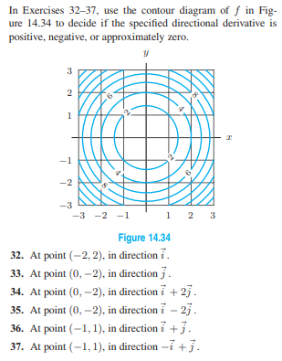



1. 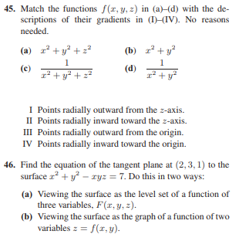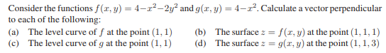

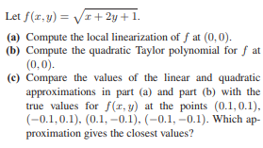

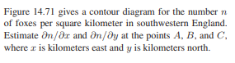

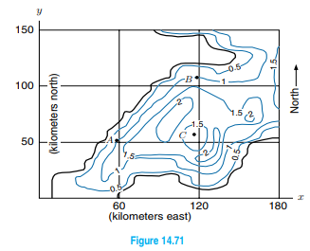



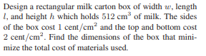

1. 